Office of the Principal
Govt. Degree College Pampore
گورنمنٹ ڈگری کالج پانپور(کشمیر)
Tulibagh, Pampore - 192121 - (Distt. Pulwama)- Kashmir
Cell: 9419022133, Web: gdcpampore.edu.in Email: gdcpampore@gmail.com

Seminar on Communication Skills for Peaceful Living’
The College Debates and Seminars Committee in collaboration with Center for Dialogue and Reconciliation, New Delhi organized a day-long seminar on ‘Communication Skills for Peaceful Living’ on 4th October 2023 in the College Conference Hall. The session was moderated by Dr Iqbal Malik, Program Coordinator while the Rapportuer duties were performed by Dr Huzaifa Pandit, Member Debates Seminars Committee. The resource persons for the session were Ms Sushobha Barve Executive Secretary, Centre for Dialogue & Reconciliation, Delhi, Ms Gurmeet Kaur, Former Associate Professor College of Education, Srinagar, and Mr. Zarief A Zarief, Poet, Historian, former cultural officer, Dept of Information & Culture. The session was well attended by faculty members and more than hundred students.
The session commenced with a welcome address delivered by the Principal who emphasized on the need of effective communication skills for better communication for conflict avoidance and minimization, and thereby a more harmonious and peaceful existence with co-beings. She insisted that sessions like these refurbish and reinforce our sense of self that is an important asset in navigating the tumultuous waters of modernist chaos. Next, Sushobha Barve delivered a talk on ‘Qualities for living peacefully’. She deliberated on the need to listening to understand rather than listening to react, in order to provide an adequate response to the demands and contexts outlined by the speaker. She highlighted the need of effective modulation of voice, and proper eye contact in order to sustain successful and peaceful communication.
Next, Ms Gurmeet Kaur delivered a talk on ‘Communication Skills in the family’. She drew attention to inter-familial dynamics and the need for empathic listening and conversing such that friction is avoided, and the family function as a cohesive emotive unit. This session was followed by Mr. Zarief A Zarief who talked on ‘Qualities for Living peacefully’. He focused on the qualities like empathy, sympathy, patience and tolerance for divergent views in order to come truly close to the cultural ethos of Kashmir which has prided itself on possessing a dynamic and vibrant ethic of communication.
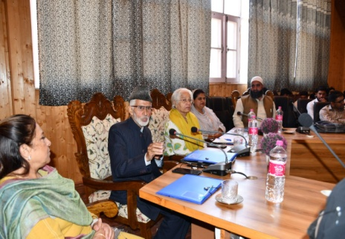
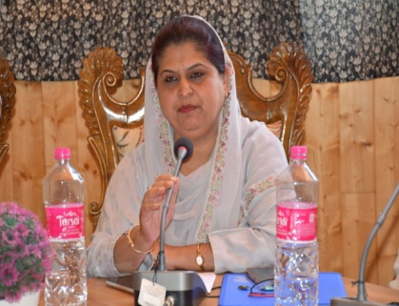
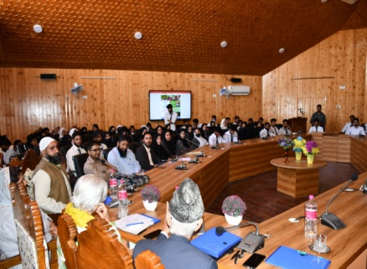
The session concluded with a formal vote of thanks by Dr. Pervaiz Ahmad, Head Department of Urdu.

Dr Huda Galzai
Principal

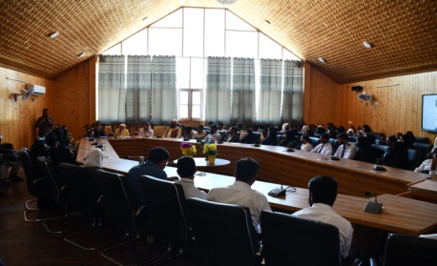
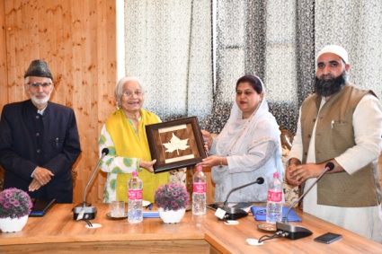
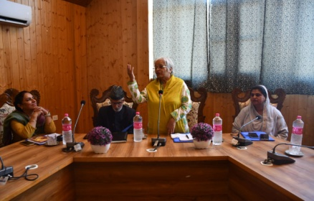

Submitted by
Dr. Huzaifa Pandit
For approval

