Office of the Principal
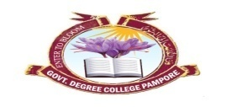
Govt. Degree College Pampore
NAAC Accredited B+
گورنمنٹ ڈگری کالج پانپور(کشمیر)
Tulibagh, Pampore - 192121 - (Distt. Pulwama)- Kashmir
Cell: 9419022133, Web: gdcpampore.edu.in Email: gdcpampore@gmail.com

World Blood Donor Day
A Report
In connection with the observance of World Blood Donor Day on 14th of June, 2023 the College NSS Unit in collaboration with the Department of Physical Education and Sports organized a series of activities to raise awareness about the importance of blood donation. The activities were conducted under the able patronage of Principal Prof. (Dr.) Huda Galzai:
- Poster Competition: The College NSS Unit organized a poster Competition on the theme ‘Give Blood, Give Plasma, Share Life, Share Often’ on 14th of June, 2023 in Lecture Hall 13 at 11:30 am. The competition was held with the aim of raising awareness about the importance of blood donation among students via the medium or art. In the said activity many students participated actively and the following bagged the first two ranks:
- Shakir Nazir, BG 5th Semester
- Nowsheeba Bashir, BG 5th Semester
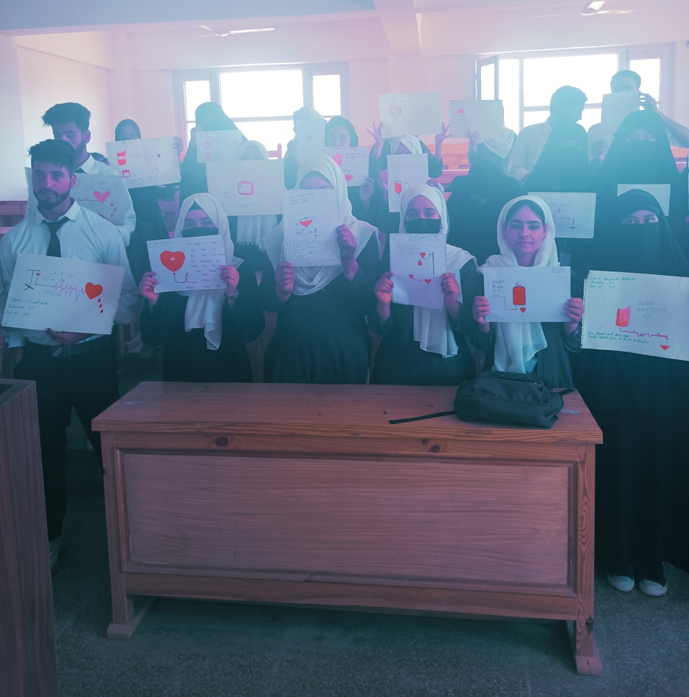
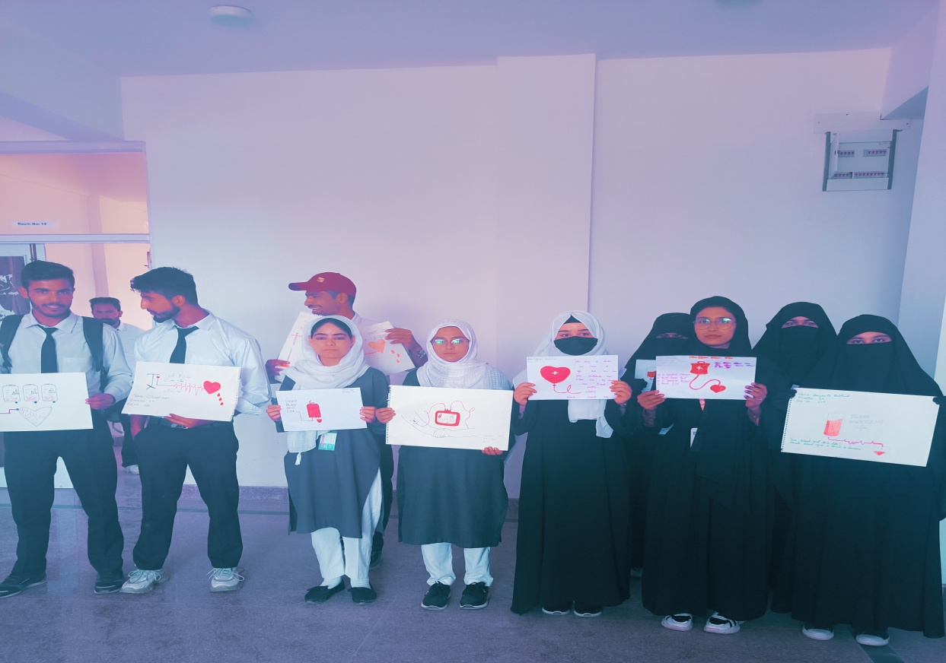

- Pledge Taking Ceremony: The College NSS Unit organized a Pledge Taking Ceremony on the eve of World Blood Donor Day on 14th of June, 2023 in Lecture Hall 13 at 12:00 pm. The pledge was read by NSS Programme Officers in which they took the resolution of donating blood actively. The pledge reads as under:
‘We the students and faculty members of Govt. Degree College, Pampore take the pledge to Give Blood, Give Plasma, Share Life, Share Often’

- Awareness Lecture: The College NSS Unit organized an ‘Awareness Lecture’ on the theme ‘Myths about Blood Donation’ on 15th of June, 2023 at 11:30 am in College Virtual Lab. The guest speaker on the occasion was Dr. Fayaz Ahmad Bhat, Medical Officer Block Pampore. The lecture focused on the importance of blood donation and the speaker addressed the various myths associated with blood donation. The lecture was followed by an active question and answer session which was followed by the concluding remarks of worthy Principal Prof. (Dr.) Huda Galzai. The session was moderated by Dr. Iqbal Malik.
