Office of the Principal
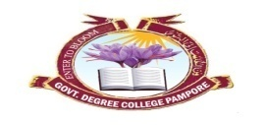
Govt. Degree College Pampore
گورنمنٹ ڈگری کالج پانپور(کشمیر)
Tulibagh, Pampore - 192121 - (Distt. Pulwama)- Kashmir
Cell: 9419022133, Web: gdcpampore.edu.in Email: gdcpampore@gmail.com
Dated:

Observance of UT Foundation Day by College Debates and Seminar Committee in collaboration with NSS Unit

A Report
In connection with the observance of UT Foundation Day the College Debates and Seminar Committee in collaboration with NSS Unit organized a series of events w.e.f. 25th of October, 2023. The events were organized under the able patronage of Principal Prof. (Dr.) Huda Galzai.

Glimpses of the event:
- Open Painting Competition: The college Debates and Seminar Committee organized an ‘Open Painting competition’ on the theme ‘Corruption Free and Poverty Free Future’on 25th of October, 2023 at 12:30 pm. In the said competition many students participated actively and expressed themselves, their ideas via the medium of art. Th following students were declared winners:
- Shakir Nazir, BG 5th Sem, R.no. 650, 1st Position
- Tabasum Gulzar, BG 1st Sem, 2nd Position
- Shah Areefa Ashraf, BG 1st Sem, R. No. 23082, 3rd Position

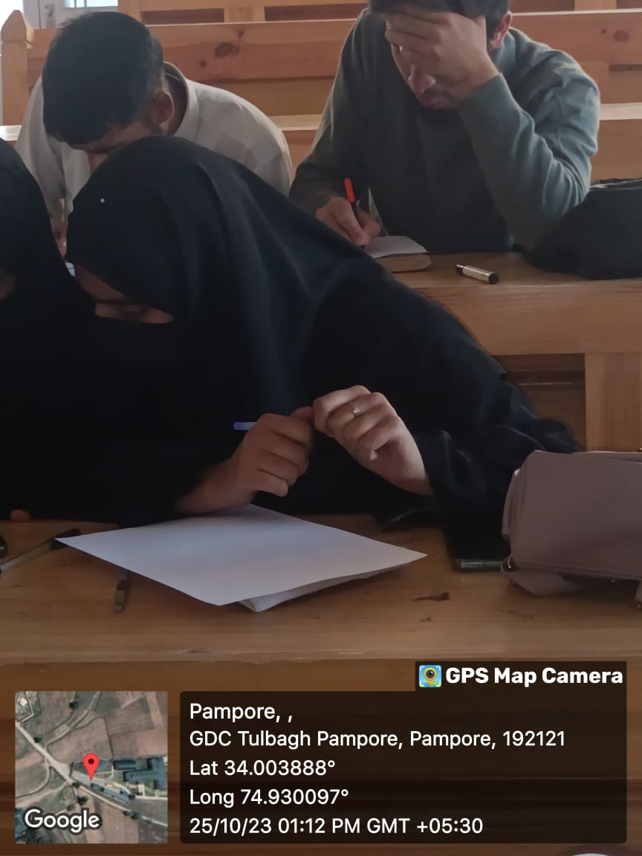

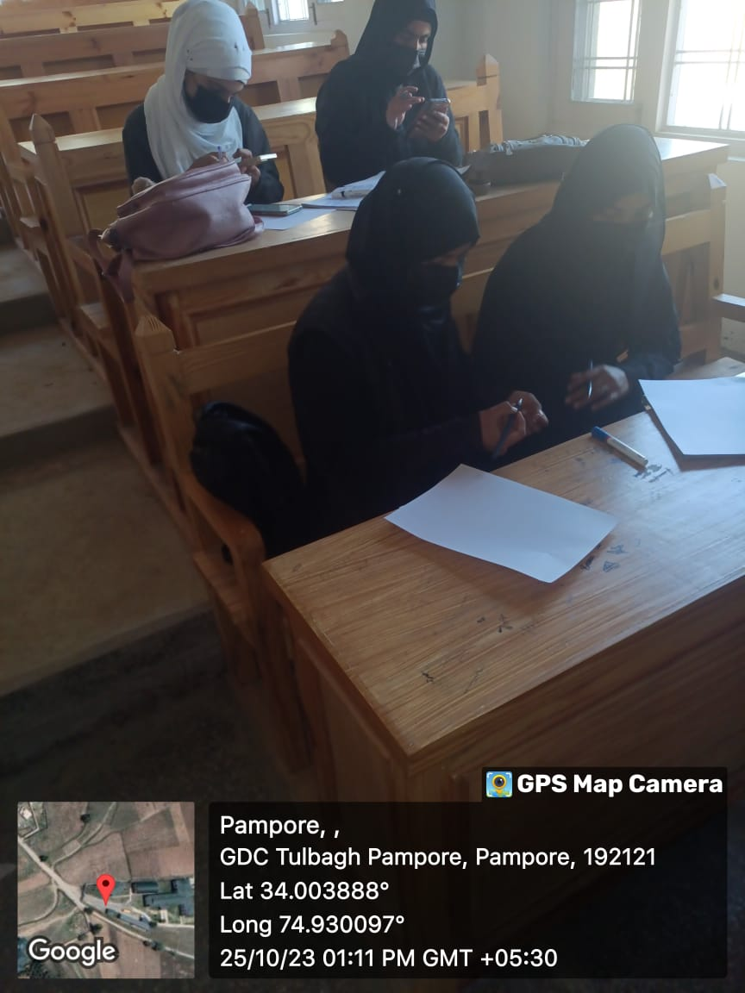

- Debate on the theme ‘Transparent and Corruption Free Adminsitration in UT of J&K’: The college Debates and Seminar Committee organized a Debate Competition on the theme ‘Transparent and Corruption Free Adminsitration in UT of J&K’ on 27th of October, 2023 at 12;00 pm in college conference hall. In the said competition numerous students participated with zeal and zest and following were declared the winners:
- Areefa Ashraf, BG 1st Sem, R. No. 23082, 1st position
- Faizan Hameed, BG 6th Sem, R. No. 108, 2nd Position
- Ishrat Reyaz, BG 3rd Sem, R.No. 225, 3rd Position

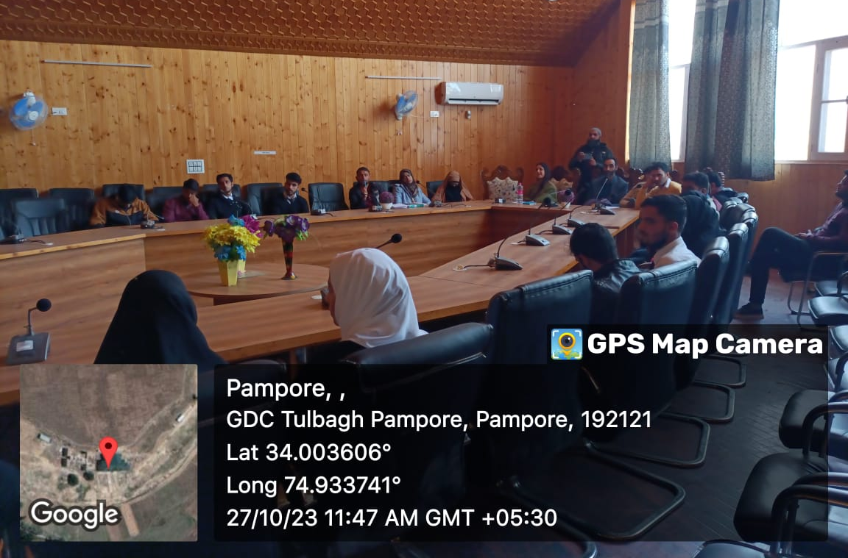
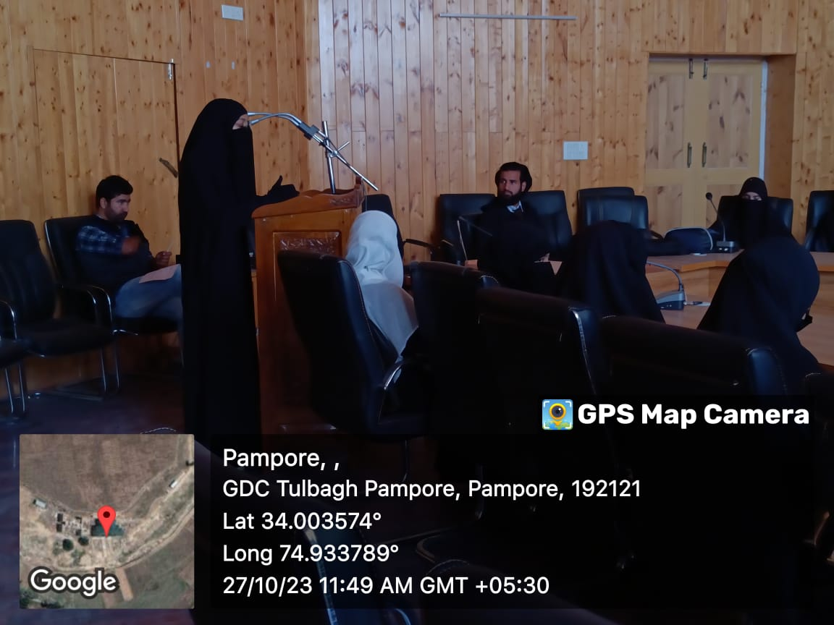

3.Quiz Competition on the theme ‘Good Governance in Jammu & Kashmir’: A quiz competition was held on 27th October 2023 on the theme of ‘Good Governance in J&K’ by the Department of Political Science in collaboration with the College Debates and Seminars Committee. The event was moderated by Dr Zubair Malik, Lecturer Islamic Studies, and reported by Dr Huzaifa Pandit, Media Secretary. The quizmaster duties were performed by Prof Aijaz Manzoor – HOD Political Science. 16 students divided into four teams: A, B, C,D participated in the quiz.
The event commenced with a brief address by Prof Aijaz on the aims and objectives of the quiz – to create awareness among students on the good governance practices in Jammu and Kashmir. The questions detailed the various practices and the histories of their evolution e.g. RTI, Back to Village Scheme, and Awaam ki Awaaz Scheme. The teams contested with zeal and energy eager to pip each other to glory. Eventually after a closely fought contest, Team C under the leadership of Ishrat Sem 3rd were declared winners. The event concluded with a vote of thanks by Dr Muneer Malik, Lecturer History.
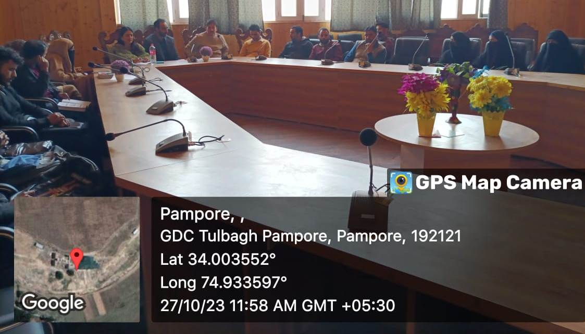

- Cleanliness Drive: The college NSS unit organized a Cleanliness Drive on 28th of October, 2023 at 2:00 pm. The college NSS Volunteers cleaned the college premises near the library block. Cleanliness drive was also conducted in college grounds in which many students and NSS Volunteers participated actively.
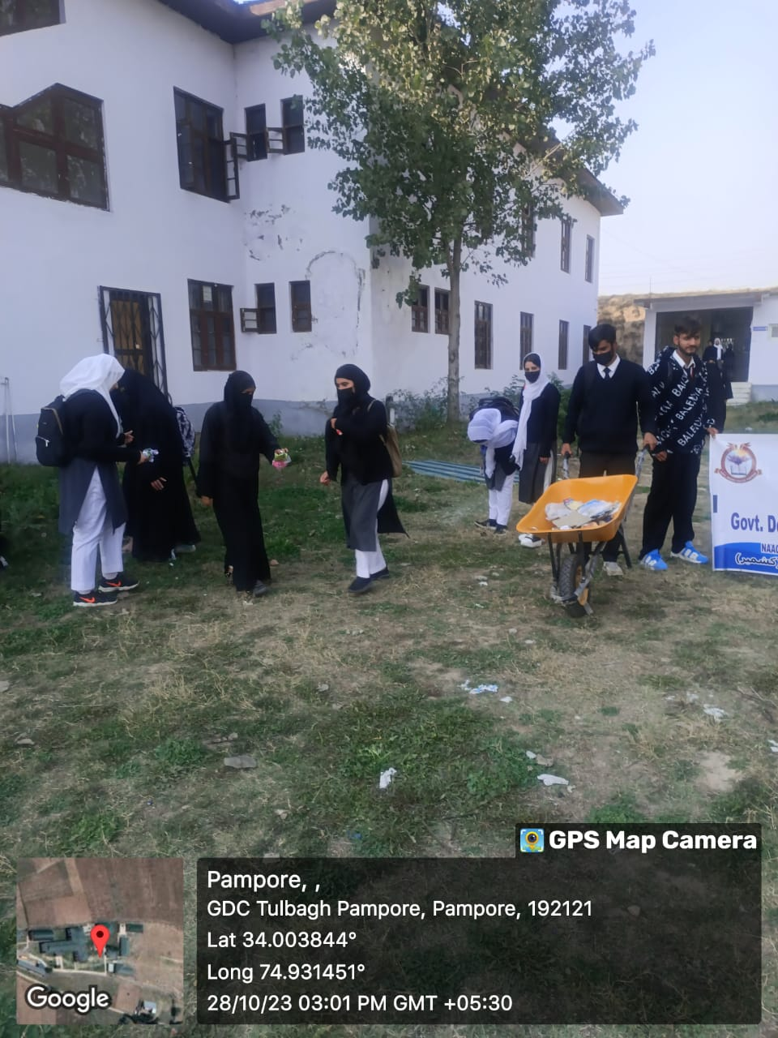

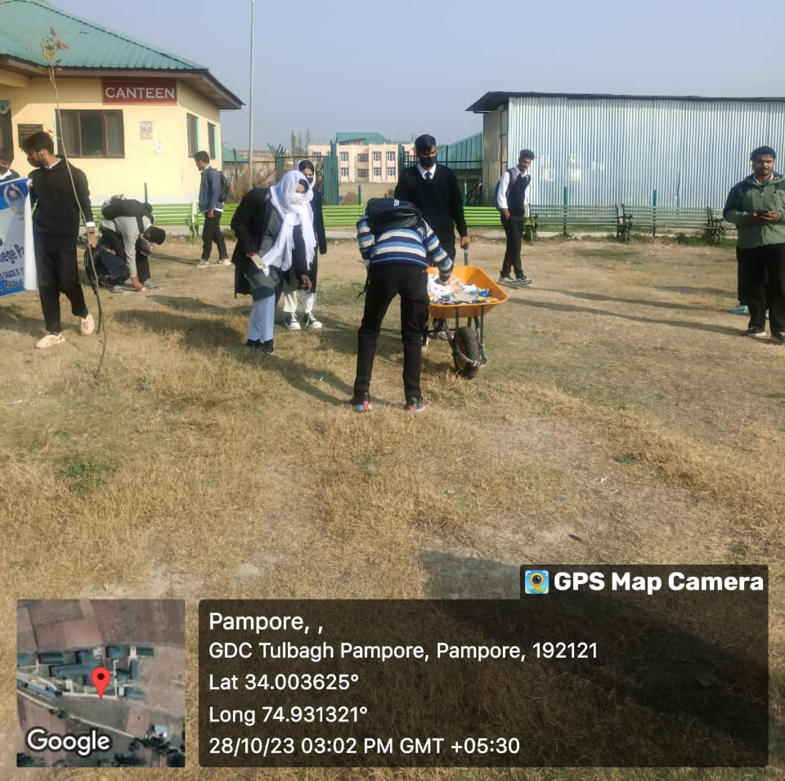

- Plantation Drive: The college Eco Club and Department of EVS organized a plantation drive on 31st of October, 2023 at 11:00 am in college park outside 8-clasroom block. In the said drive various tree saplings were planted by students, eco club members and faculty members.
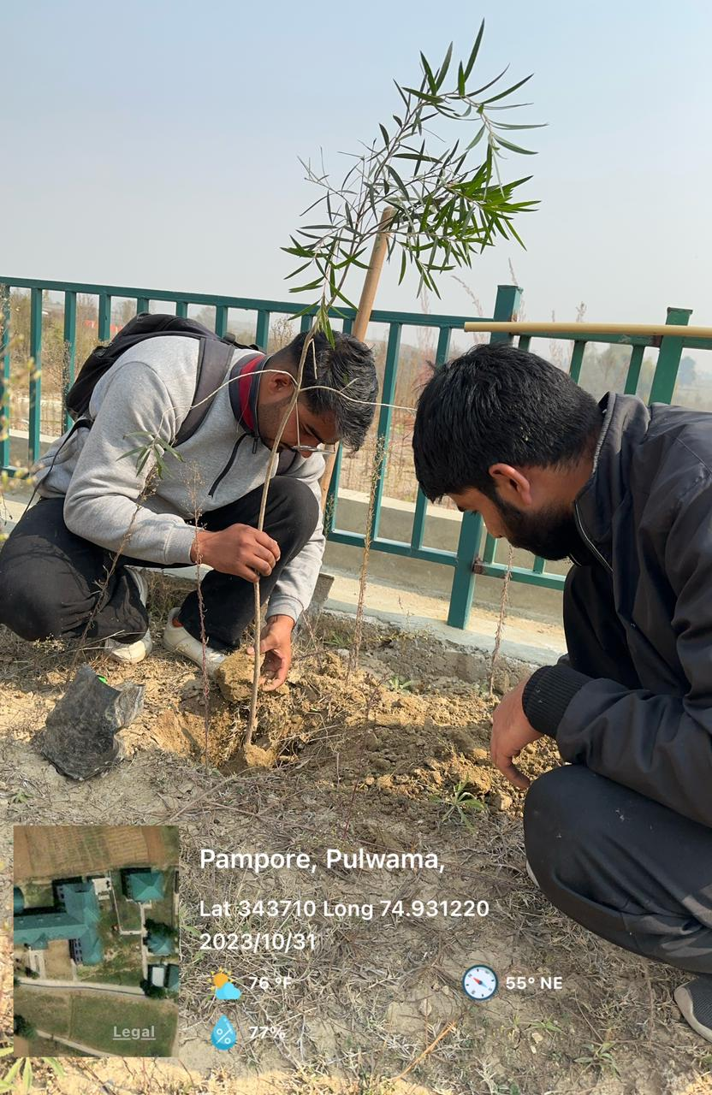
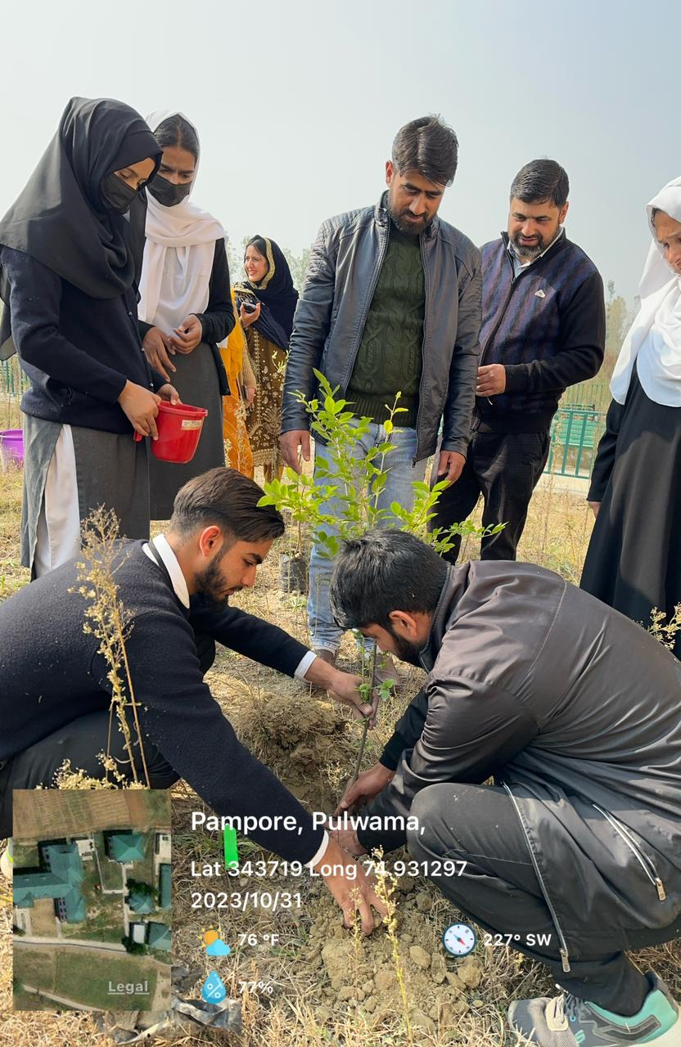

Submitted for approval

