Office of the Principal
Govt. Degree College Pampore
NAAC Accredited B+
گورنمنٹ ڈگری کالج پانپور(کشمیر)
Tulibagh, Pampore - 192121 - (Distt. Pulwama)- Kashmir
Cell: 9419022133, Web: gdcpampore.edu.in Email: gdcpampore@gmail.com

Observance of 9th International Yoga Day on 21st of June, 2023 organized by NSS in Collaboration with RRC and Department of Physical Education & Sports under the banner of Mission Life

A Brief Report
In connection with the Observance of 9th International Yoga Day on 21st of June, 2023 the college NSS Unit, RRC and Department of Physical Education & Sports under the banner of Mission Life organized a series of activities. The programme was conducted under the able patronage of Principal Prof. (Dr.) Huda Galzai. The programme commence with an Inaugural Address by Principal Prof. (Dr.) Huda Galzai in which she focused upon the need of organizing such events and exhorted the students to participate actively in such activities.
Brief Snippets of the Activities:
- Lecture on the theme ‘Importance of Yoga in our lives’: An awareness lecture on the theme ‘Importance of Yoga in our lives’ was organized on 21st of June in college multipurpose hall at 11:30 am. The lecture was delivered by Mr. Zafar Manzoor. Head Department of Physical Education and Sports in which he deliberated upon origin of Yoga and its significance in current times. He also spoke about the need of including this habit of doing yoga in our daily routine. In the lecture many students, nss volunteers and faculty members participated actively.
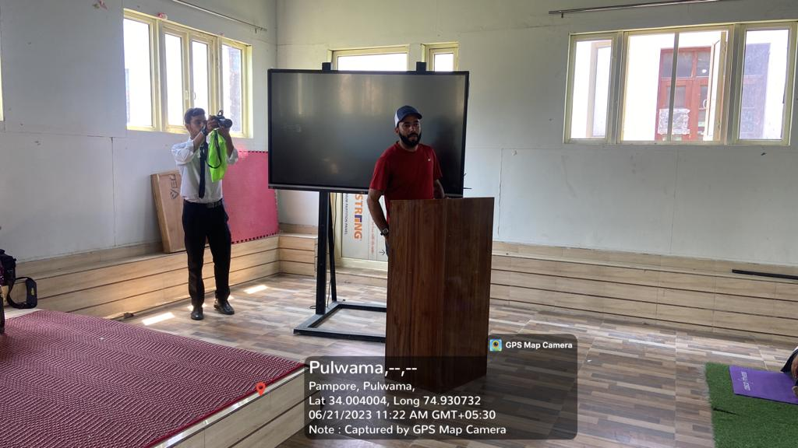
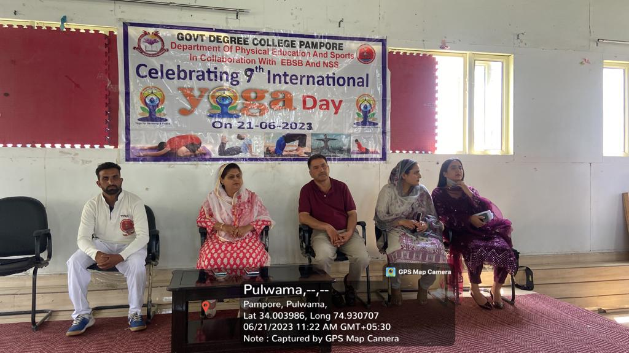
- Familiarizing the concept of ‘Y-Breaks’: A brief and crisp lecture on the concept of Y-Breaks was delivered by Mr. Zafar Manzoor in college Multipurpose Hall in which he spoke about the growing need of distressing ourselves and taking short Y-Breaks in our busy schedules.
- Yoga Demonstration Session: Moreover a Yoga Demonstration Session was conducted by Mr. Sheeraz Ahmad, Yoga Trainer from Youth Services and Sports in Multipurpose Hall in which many students and NSS Volunteers participated. The Yoga Trainer demonstrated many Yog-Asanas in front of students and students practiced these various asanas.
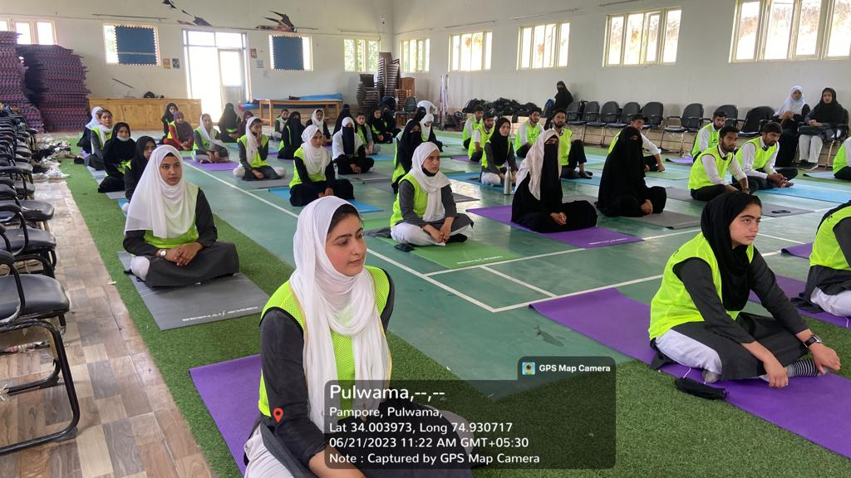
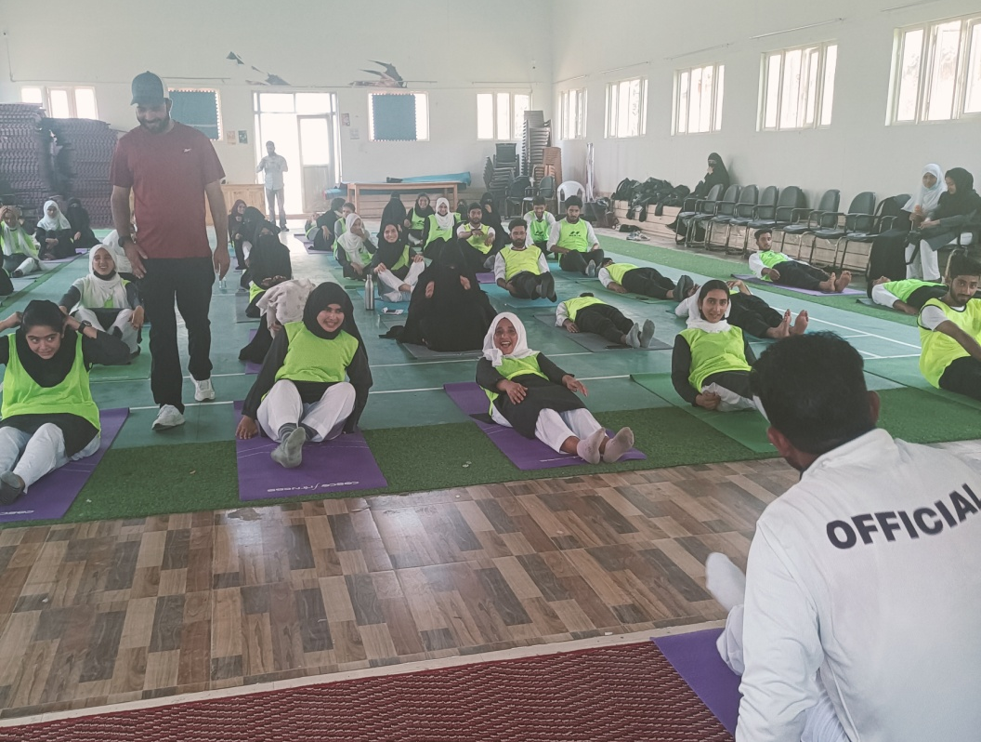
- Pledge Taking Ceremony: A pledge Taking Ceremony was conducted to promote the importance of Yoga in college multipurpose hall at 12:30 pm. In the ceremony many students, NSS volunteers and faculty members along with Madam Principal participated. The pledge read as under:
“We take pledge to integrate yoga in our life by practicing yoga regularly with our family and friends and also encouraging them to adopt yoga for a healthy lifestyle.”
- Poster/Painting Competition on the theme ‘Importance of Yoga in our lives’: In order to promote the importance of yoga in our lives via the medium of art a painting/poster competition was held among students in college multipurpose hall. In the competition many students participated and painted/sketched various informative and beautiful posters and paintings. The following were declared the winners:
1st position: Rabia Mushtaq, BG 2nd sem, Roll No.20220441
2nd position: Mehak Fayaz, BG 2nd Sem, Roll No. 20220485
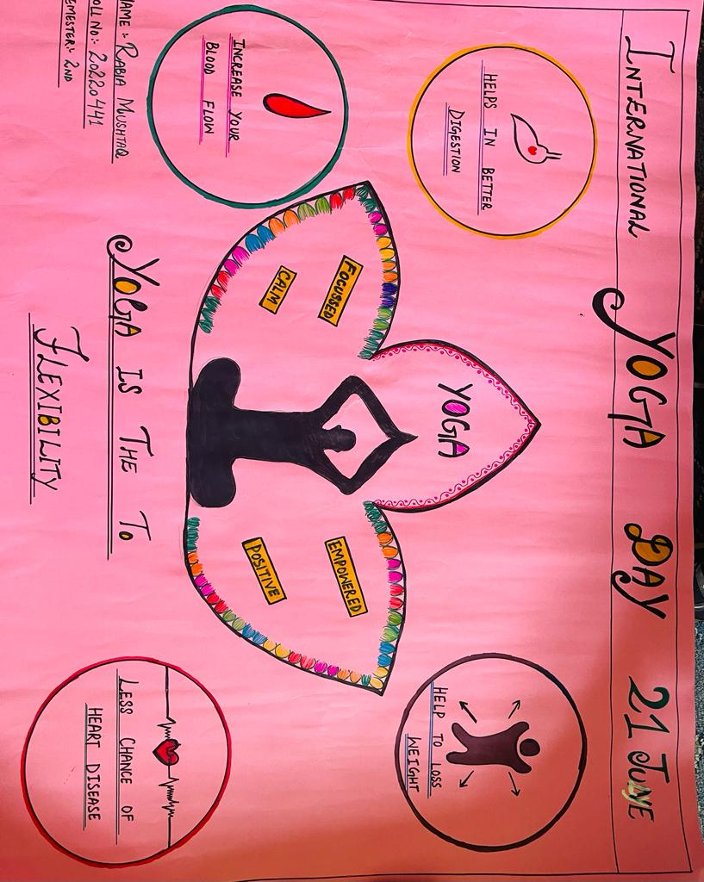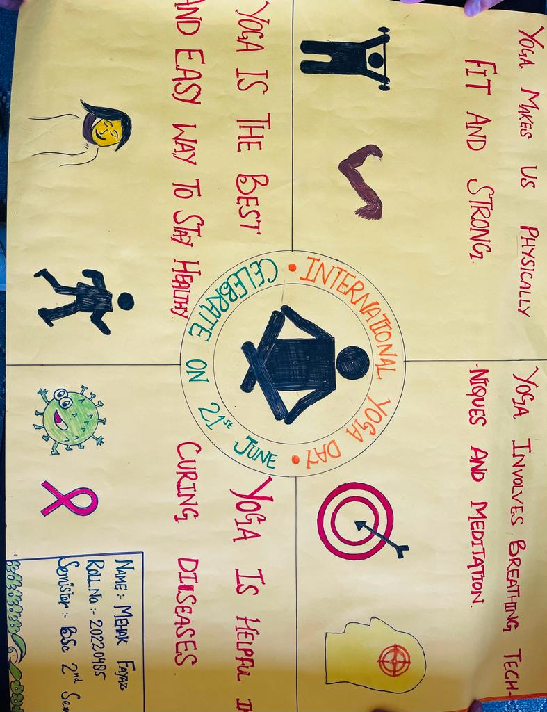 Submitted for approval

