Office of the Principal
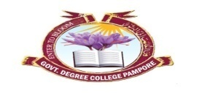
Govt. Degree College Pampore
NAAC Accredited B+
گورنمنٹ ڈگری کالج پانپور(کشمیر)
Tulibagh, Pampore - 192121 - (Distt. Pulwama)- Kashmir
Cell: 9419022133, Web: gdcpampore.edu.in Email: gdcpampore@gmail.com

Observance of World Environment Week organized by College NSS Unit in collaboration with Eco-Club, Department of Environmental Sciences and Department of Physical Education, Innovation, Incubation Cell (IIC) and Sports, Debates and Seminar Committee under the banner of Mission Life

A Report
In Connection with the observance of World Environment Week, the College NSS Unit in collaboration with Eco-Club, Department of Environmental Sciences and Department of Physical Education and Sports, Debates and Seminar Committee under the banner of Mission Life organized a list of activities w.e.f 1st of June, 2023. The activities were conducted under the able patronage of Principal Prof. (Dr.) Huda Galzai:
- Poster/Painting Competition on the theme ‘Beat Plastic Pollution’: The College NSS Unit, Debates & Seminar Committee and Department of EVS organized a poster/painting competition on the theme ‘Beat Plastic Pollution’ on 1st of June, 2023 at 12:00 pm. The Competition was organized with the aim of bringing about awareness among students regarding the growing menace of plastic in our society. In the said competition numerous students participated enthusiastically and drew many interesting paintings and posters. The below listed students were declared winners by jury members Prof. Irfan Khursheed Shah, HOD Evs and Mr. Jahangeer Mohammad:
1. Anzar Manzoor, 2nd Semester, Roll No. 91
2. Mehnaza, 2nd Semester, Roll No. 140
3.Irshad Ahmad Dar, 2nd Semester, Roll No. 94
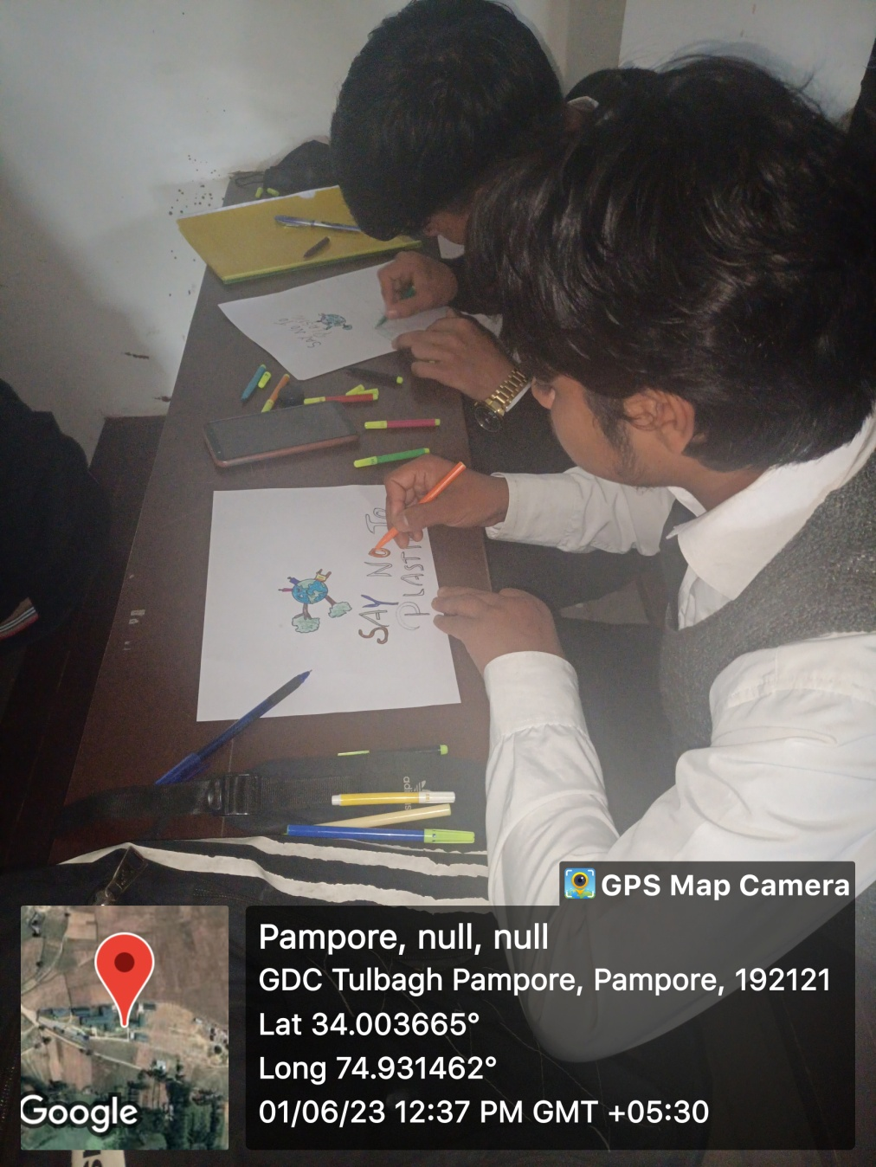
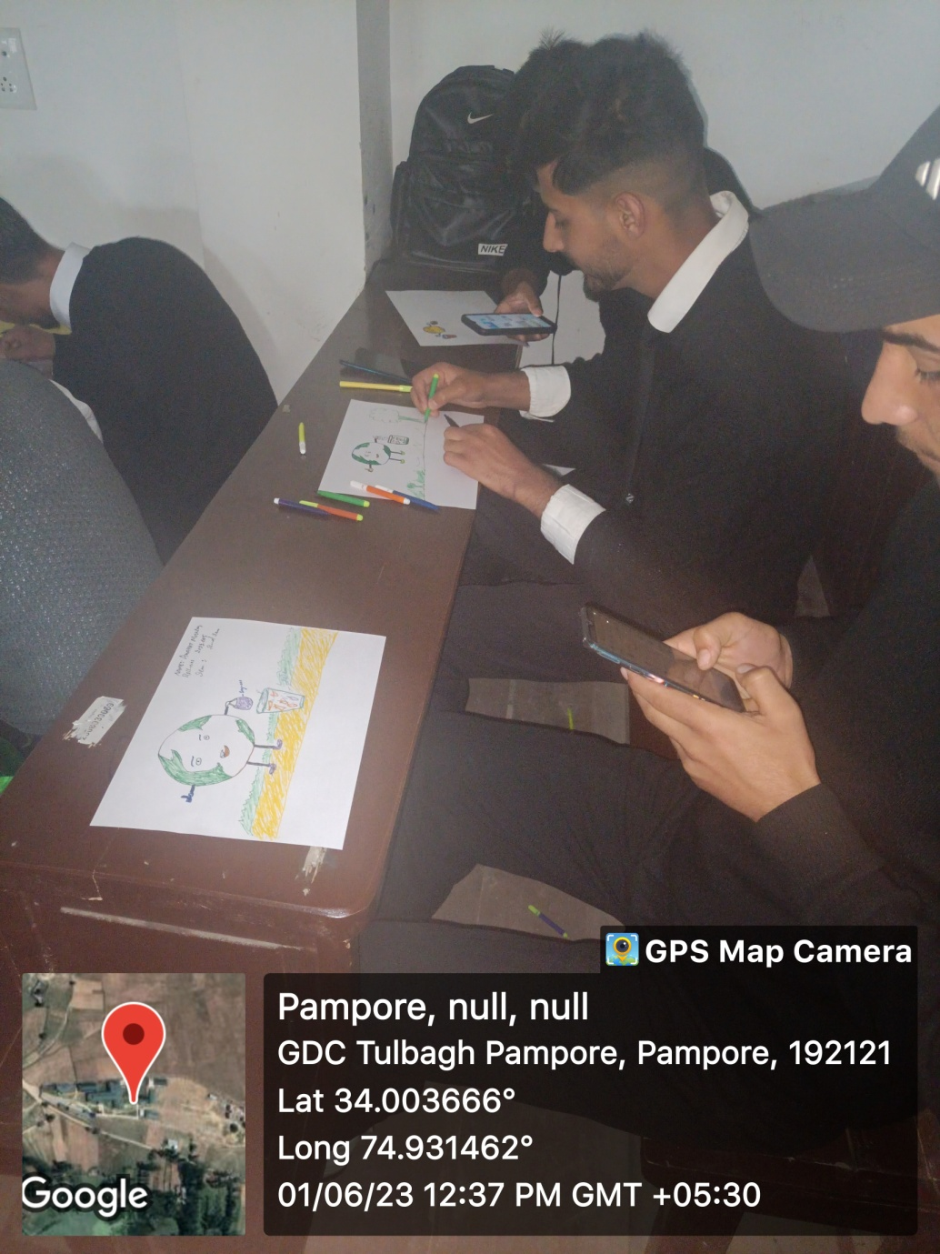
- Cleanliness Drive: The College NSS Unit and Eco-Club organized a Cleanliness Drive on 3rd of June, 2023 at 1:00 pm. The Cleanliness Drive was held within the college campus in which numerous Nss Volunteers and Eco-Club Members participated actively. In the said drive volunteers cleaned the college Library Block and the garden adjoining it.
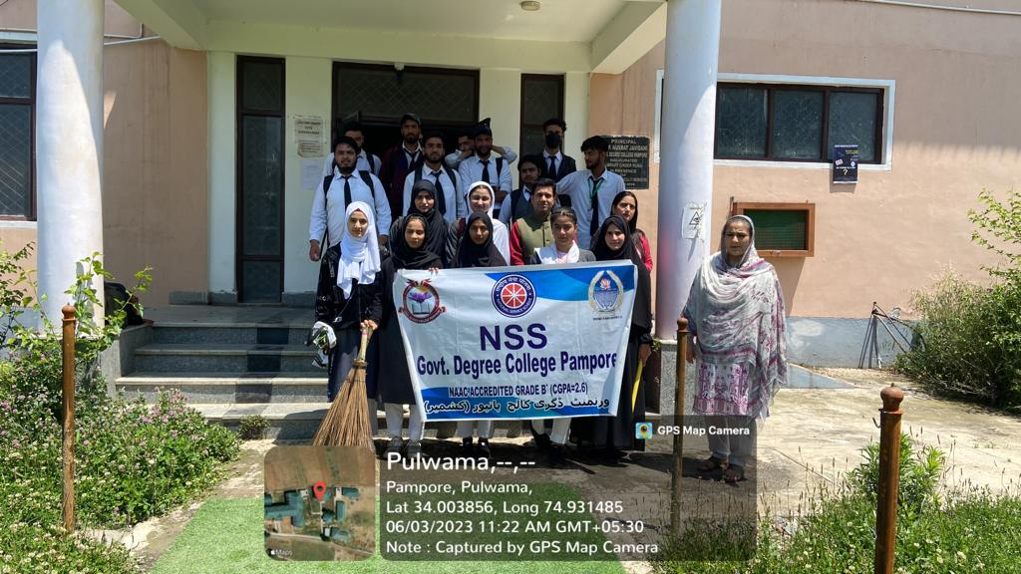

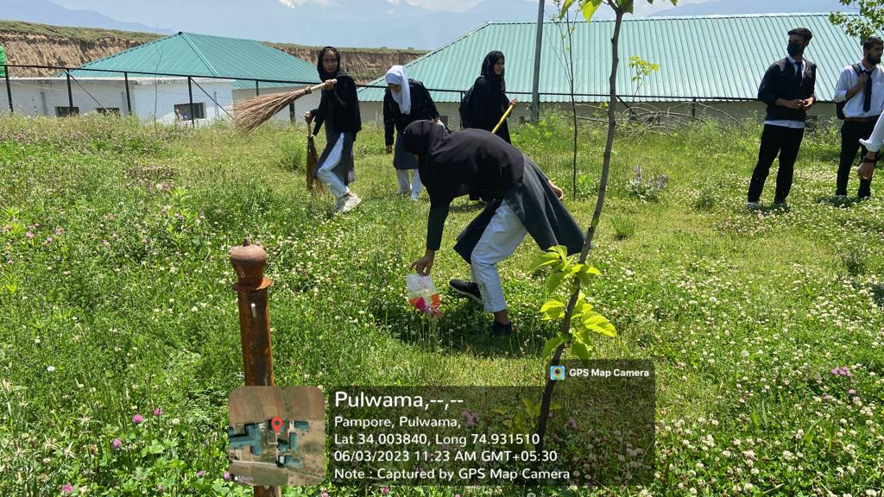

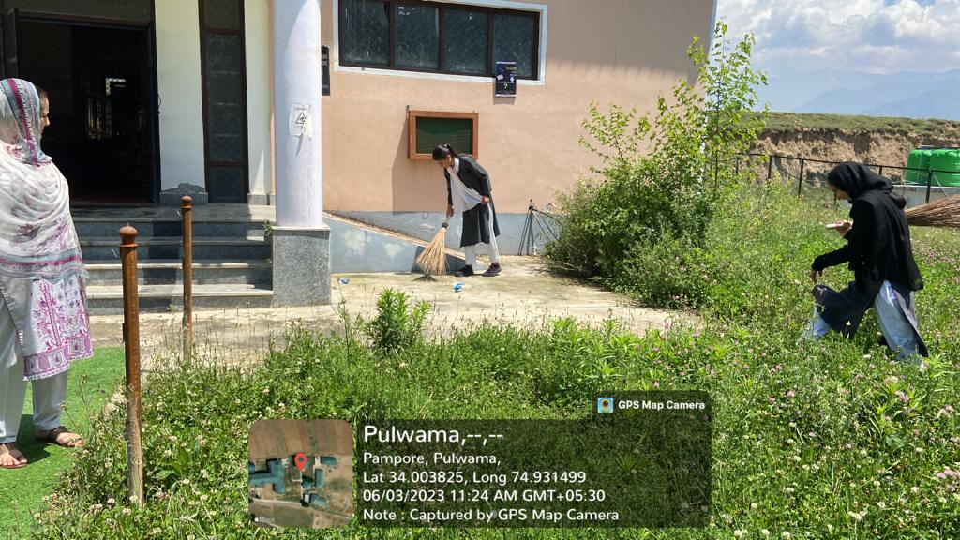

- Cyclethon: Peddle For Environment (Burn Fat, Not Fuel): The Department of Physical Education and Sports along with NSS Unit and Eco-Club organized a Cyclethon on the theme ‘Burn Fat, Not Fuel’ on 3rd of June, 2023 at 11:00 am. The Cyclethon was flagged off by College Staff Secretary Prof. Hilal Ahmad Bakshi and NSS Programme Officer Prof. Alam Ara Shah from the college Gate no. 01. The Cyclethon aimed at raising awareness among masses about the importance of cycling and minimizing the use of fuel based automobiles. In the Cyclethon many students participated actively.
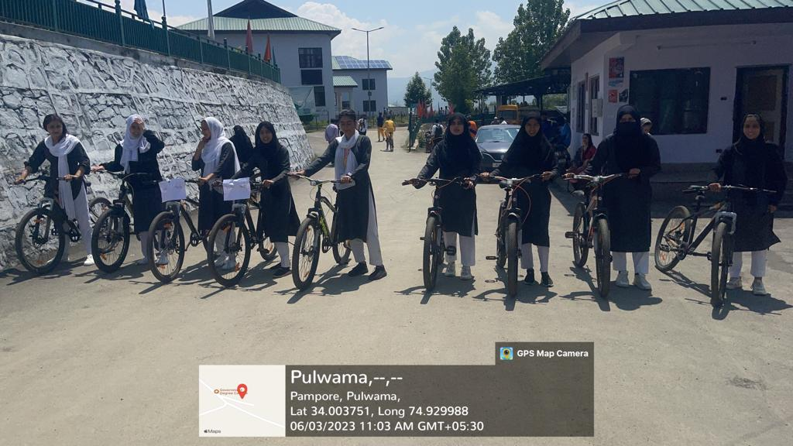
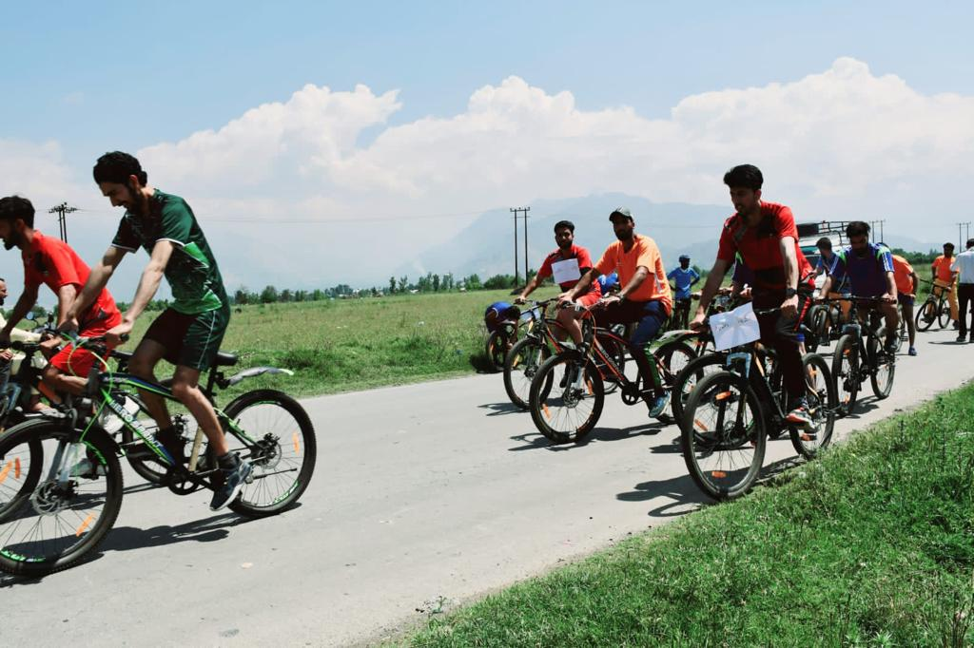
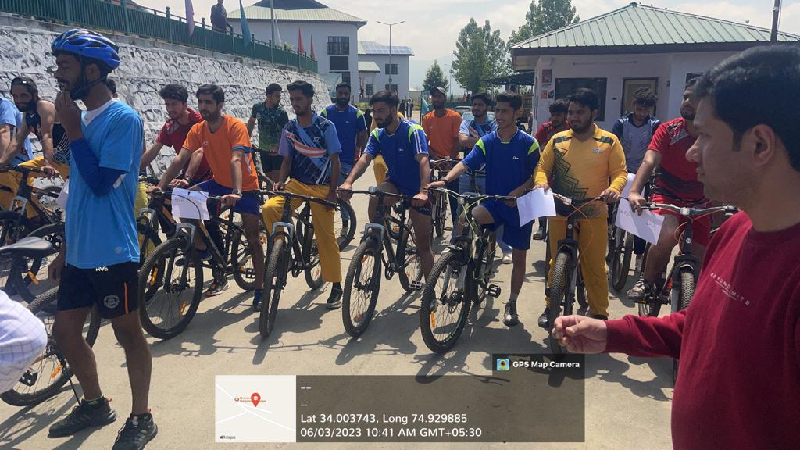
- Short Informative Videos on the ‘Importance of Bicycling’ by College Staff: In order to raise awareness among young budding students the college staff members took the initiative of recording short informative videos on the theme ‘Importance of Bicycling’. Prof. Hilal Ahmad Bakshi, college staff secretary took the lead in giving a very significant message to students by deliberating upon the various health benefits of bicycling. Prof. Alam Ara Shah also gave a very informative message in her short recorded video. The activity was held on 3rd of June, 2023 at 11:00 am.
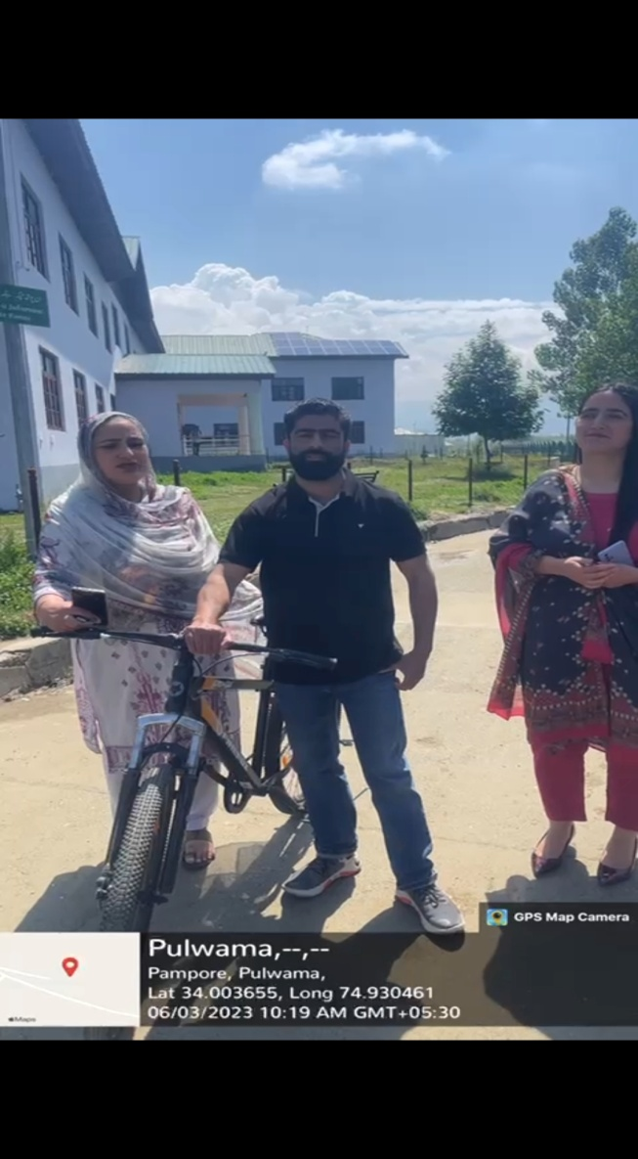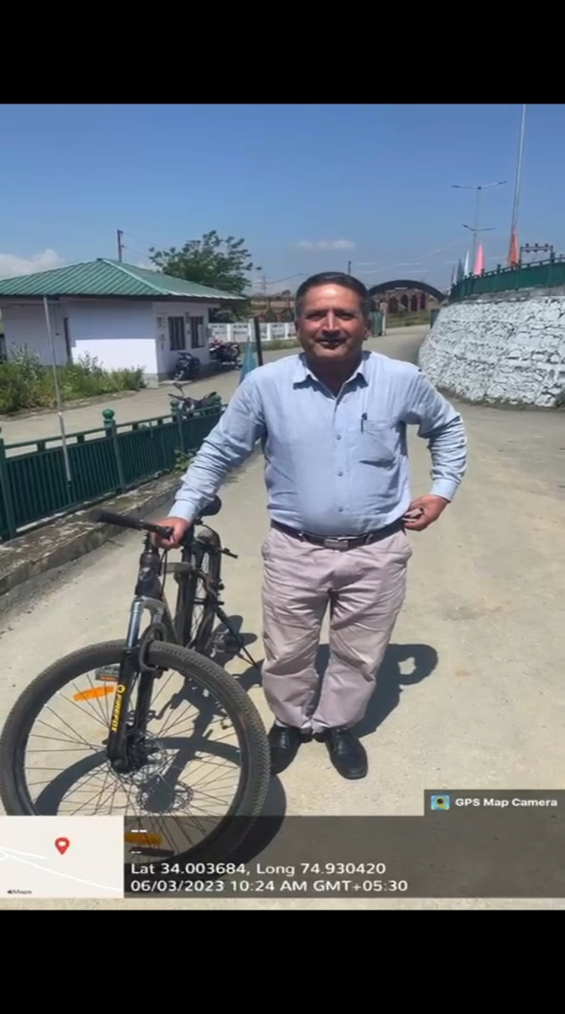

- Poster Competition on the theme ‘Burn Fat, Not Fuel’: The College NSS Unit in collaboration with the Department of Physical Education and Sports organized a Poster Competition on the theme ‘Burn Fat, Not Fuel’ on 3rd of June, 2023 at 2:00 pm in Lecture Hall 13. The Competition was organized with the aim of providing awareness to students about the significance of bicycling via the medium of art. In the said competition many students participated actively and the following students were declared winners:
- Shakir Nazir, BG 5th Semester
- Midhat Majeed, BG 2nd Semester

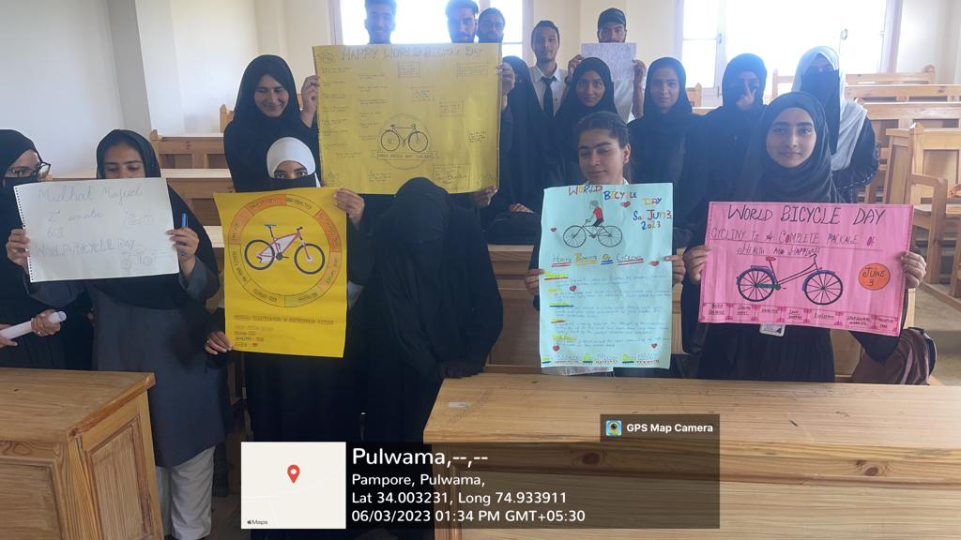

- Awareness Lecture on ‘Achieving Sustainable Development Goals’: In continuation the college NSS Unit, Department of Evs and Eco-Club organized an Awareness Lecture on ‘Achieving Sustainable Development Goals’ in college Virtual Lab on 5th of June, 2023 at 1:00 pm. The guest speaker on the occasion was Dr. Sajad Ul Akbar, Scientist SKUAST-K. The lecture focused on the growing need of saving our planet earth and taking some concrete steps in the way. The Guest speaker deliberated on the importance of following sustainable development goals in our lives. In the said event many students, NSS volunteers and Eco-Club members along with college staff participated actively.
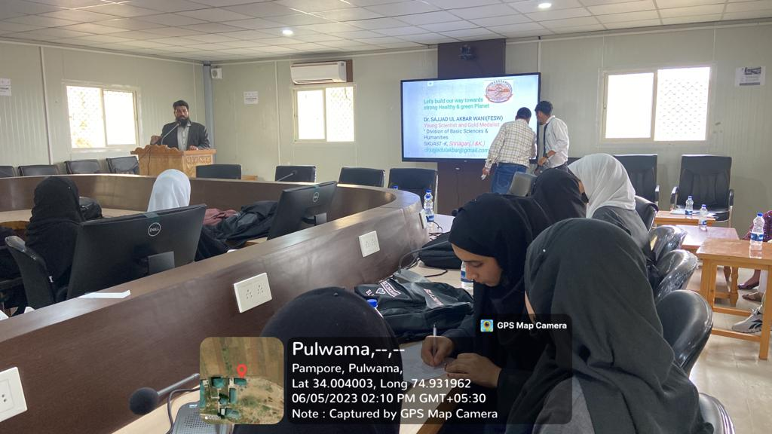
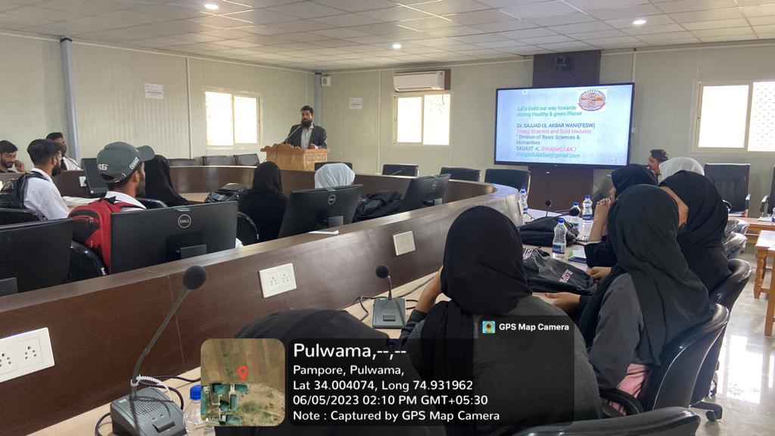

- Principal’s Conclave on ‘Climate Change and Education on Sustainable Development Goals’: The College in collaboration with Climate Reality Project and WCF organized a Principal’s Conclave on ‘Climate Change and Education on Sustainable Development Goals’ in the college virtual lab on 5th of June, 2023. The Programme was attended by many college principals and other school incharges. The event started with the welcome Address by Mr. Nadeem Qadri, Exective Director WCF in which he welcomed all the participants from schools and colleges and presented a detailed outline of the programme. After this, a
deliberated upon the issue of Climate Change and its associated challenges. Later on Dr. Rekha Lalla held an interactive session with participants and discussed various aspects of climate change solutions which can deliver economic benefits and improve our lives as well. Moreover, she taught the participants various methods of making our campus green and clean which was followed by a question and answer session. Towards the conclusion, the students of GDC Pampore presented a group song with the message of Environment Conservation.
The event concluded with a formal vote of thanks by Mr. Nadeem Qadri and the event was moderated by Dr. Irfan Khursheed Shah.
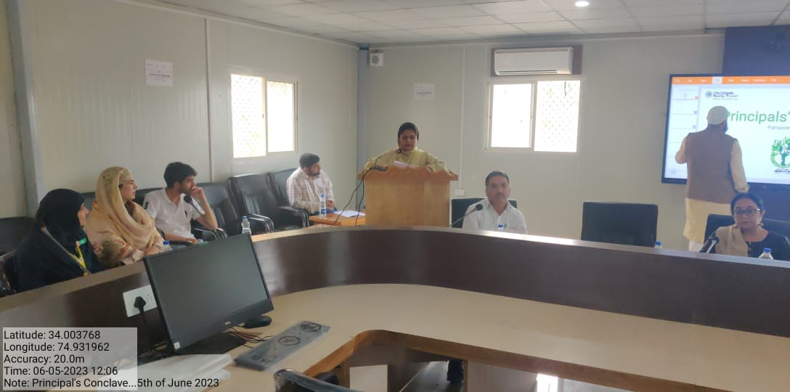

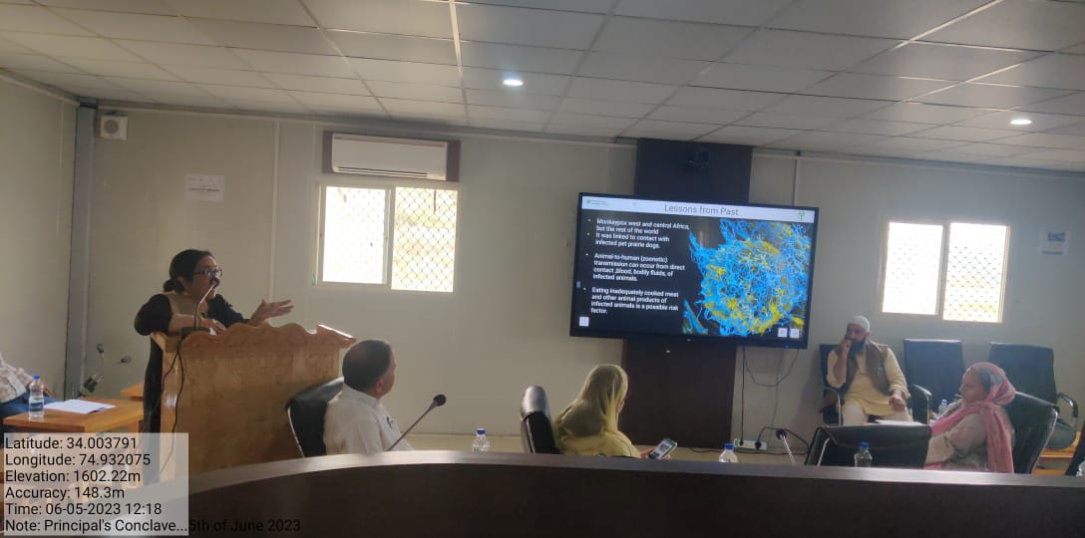
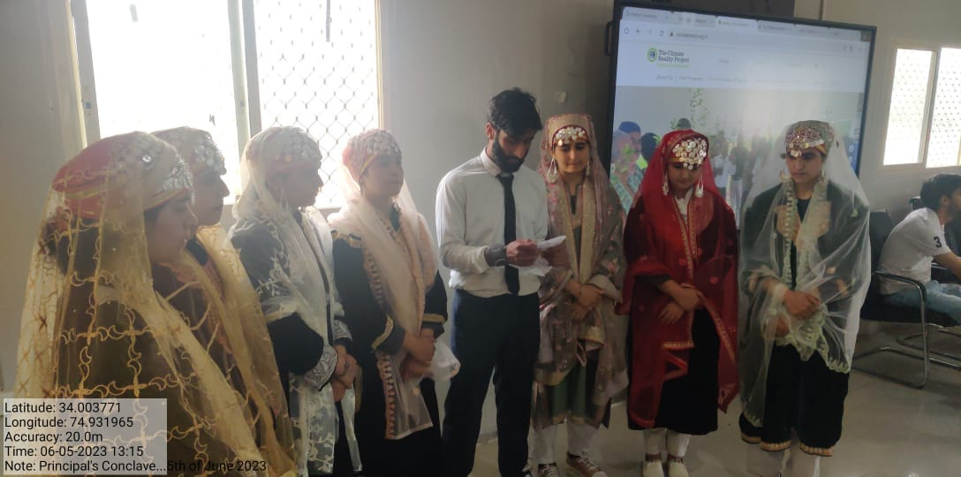

- Valedictory Ceremony: To conclude the series of events held to observe World Environment day the College NSS Unit organized a Valedictory Ceremony on 12th of June, 2023 in college Virtual Lab at 1:00 pm. The ceremony started with a display of various activities conducted throughout the week and presented a panaroma of activities conducted by various committees and departments. The slide show was presented by Dr. Irfan Khursheed Shad, Convenor Eco-Club. It was followed by short speeches by college students Mir Mohammad Wahid and Sakeena Nisar who deliberated on the importance of Environment Conservation. After the speeches, Madam Principal Prof. (Dr.) Huda Galzai delivered her concluding remarks in which she deliberated upon the need of saving our planet earth by taking concrete steps in this regard. She congratulated the college NSS Unit and various other committees in playing their role actively to organize such events. In conclusion, the students who participated in various activities were felicitated with certificates to acknowledge their efforts and active participation.
