Parent Teacher Meet organized by the Internal Quality Assurance Cell (IQAC), GDC Pampore
A Report
As a Quality Initiative, the college Internal Quality Assurance Cell (IQAC) organized a ‘Parent Teacher Meet’ on 29th July, 2021. The whole meet was organized under the able patronage of the college Principal Prof. (Dr.) Seema Naz. The meet was divided into two sessions- Session I for the General Interaction Parents with the Faculty of Arts and Humanities; Session II for the General Interaction of Parents with the Faculty of Science and Commerce. The meet was organized online via Zoom Platform and a total of 100 students along with their parents participated in it.
The Meet commenced with the welcome address by the College Principal Prof. (Dr.) Seema Naz who welcomed all the parents warmly. The Welcome address was followed up by two sessions.
In the first session the parents interacted with the faculty of Arts and Humanities and shared their opinions, suggestions with them. They applauded the efforts of the esteemed College Principal Prof. (Dr.) Seema Naz in making the college a learning hub.
In the second session, the parents interacted with the faculty members of Science and Commerce and applauded the efforts of faculty members in teaching during the tough COVID times. They shared their concerns regarding various issues related to online classes and the respected Principal of the college assured them of taking every step to make teaching-learning process more flexible and student friendly.
The whole meet was moderated by Prof. Shah Lateef, Convenor IQAC, GDC Pampore and the rapporteur of the meet was Prof. Aaliya Bashir, Dean Students.
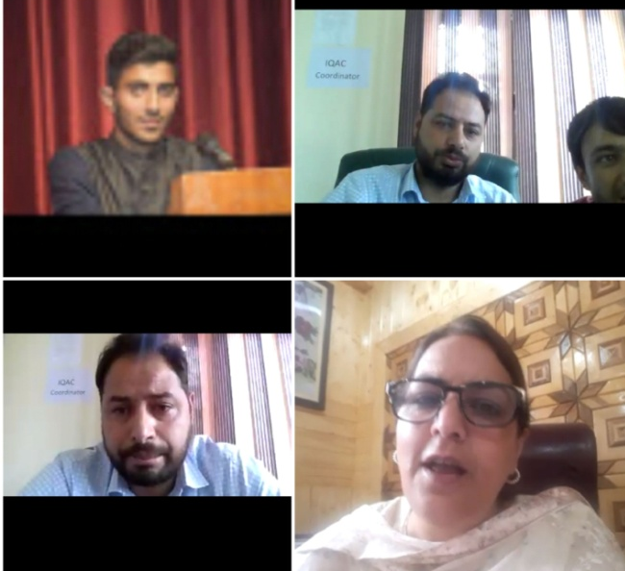
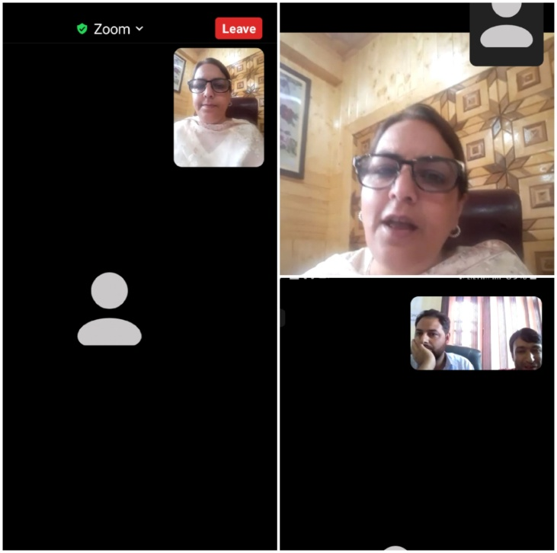

Submitted by
Ms. Aaliya Bashir
Dean Students

