Office of the Principal
Govt. Degree College Pampore
NAAC Accredited B+
گورنمنٹ ڈگری کالج پانپور(کشمیر)
Tulibagh, Pampore - 192121 - (Distt. Pulwama)- Kashmir
Cell: 9419022133, Web: gdcpampore.edu.in Email: gdcpampore@gmail.com

Pledge Taking Ceremony ‘Panch Pran’ under the banner of Azadi ka Amrit Mahotsav organized by College NSS Unit

A Report
In connection with the celebrations of 75 years of India’s Independence the College NSS unit organized a Pledge taking Ceremony ‘Panch Pran’ under the banner of Azadi Ka Amrit Mahotsav. The pledge was taken in the college conference hall at 12:30 pm on 2nd of August, 2023. The pledge was read by NSS Programme Officer Prof. Alam Ara Shah in which many students, NSS volunteers and faculty members participated actively. The pledge read as under:
“On the completion of 75 years of Independence we take a pledge
- To work for developed India and help it regain its rightful place as Vishvaguru by 2047
- To remove any traces of colonial mindset
- To take pride in our cultural and spiritual heritage
- To strengthen the unity of our nation and protect it from disruptive elements
- To carry out our duties as a citizen of this nation with honesty and to become central pillars that support India’s journey in the Amrit Kaal.”
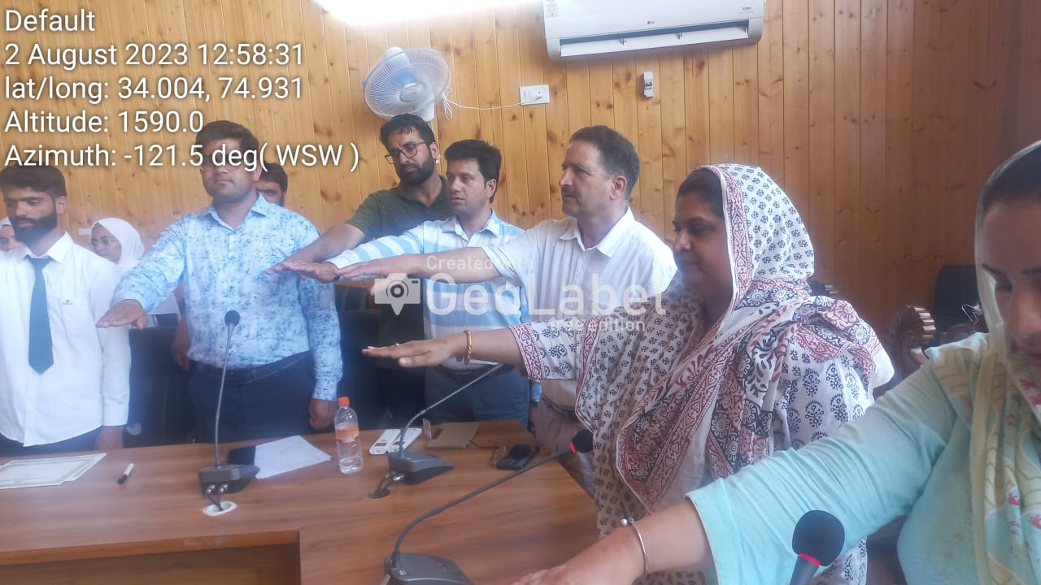
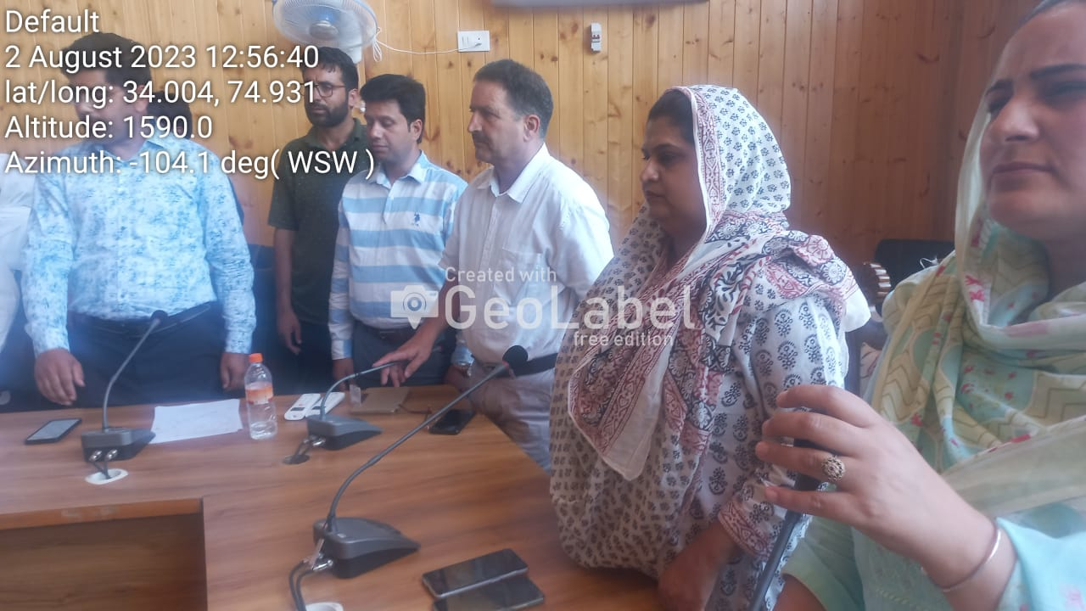

Submitted for approval

