Office of the Principal
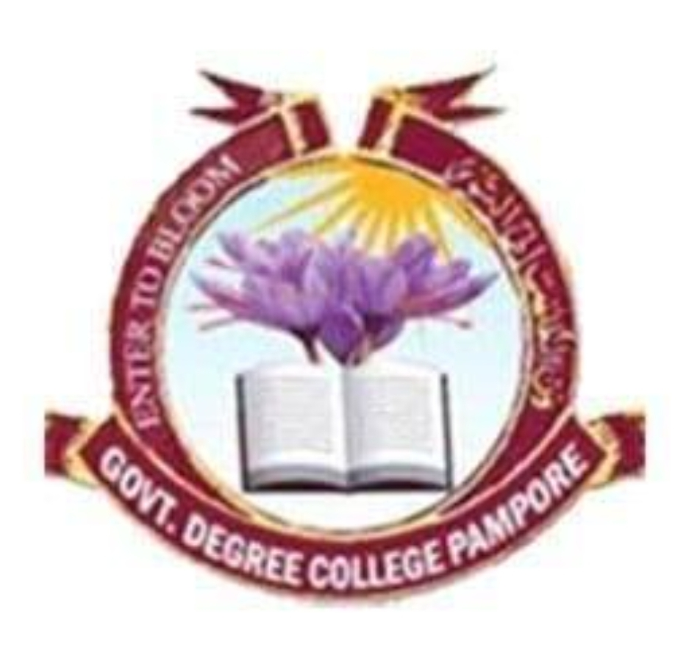
Govt. Degree College Pampore
NAAC ACCREDITED GRADE B⁺ (CGPA=2.6)
گورنمنٹ ڈگری کالج پانپور (کشمیر)
Tulbagh, Pampore-192121-(Distt. Pulwama)-Kashmir
Cell: 9419022133, web: gdcpampore.edu.in, email: gdcpampore@gmail.com

Report of National Youth Week held from 12th January, 2024 to 16th January, 2024.
To celebrate the national youth week NSS unit of the GDC Pampore organized various programmes and activities from 12th of January,2024 to 16th of January 2024 under the able guidance of worthy Principal of the College Prof. (Dr.) Huda Galzai. The purpose of celebrating the national youth week is to pay tribute to Swami Vivekananda, to promote his teachings among the youth, to highlight his contributions and to promulgate his Philosophy and ideals.
Day -1 Report: On 12th January 2024 a screening of live telecast of the Inaugural ceremony of national youth festival from Nasik, Maharashtra was held at 12:30 Pm. Prime minister Narendra Modi Inaugurated the festival and addressed the whole nation from Nasik, Maharashtra. The live telecast was watched by the worthy Principal of the College Dr. Huda Galzai along with teaching staff, non teaching staff and students. The experience of attending the live telecast of the inaugural speech presented by Narendra Modi was inspiring and enlightening. Earlier before the live telecast of inaugural ceremony of youth festival a special lecture on the teaching of Swami Vivekananda and a campus cleanliness drive was held by NSS Unit of the College. The lecture was delivered by Prof. Kasira NSS Programme Officer. In her lecture she threw light on various teachings of the Swami Vivekananda like importance of being persistent, having courage to face troubles, believing in yourself, being selfless, being honest, having a good character, importance of empathy, importance of meditation etc,. Principal Dr. Huda Galzai gave a presidential address during the event. In her address she talked about the role of youth in making India developed and how through skill based education we can make our youth productive. She also praised the efforts of the organizers for organizing the programme and also appreciated the students for participating in various activities of the college. The lecture was followed by a cleanliness drive in the college premises which was attended by a large number of students and faculty. The programme was moderated by Aateya Bashir a student of 3rd semester and a vote of thanks was proposed by Dr. Shabir Ahmad Lone, head department of Chemistry

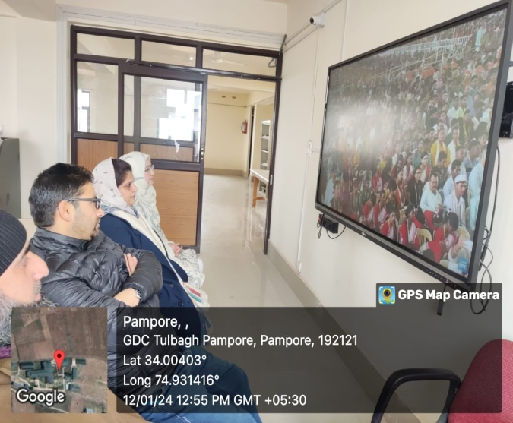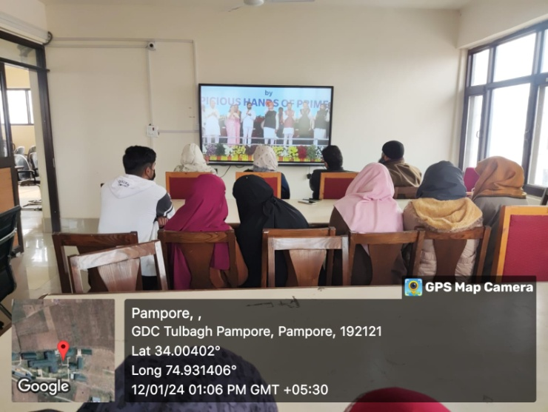
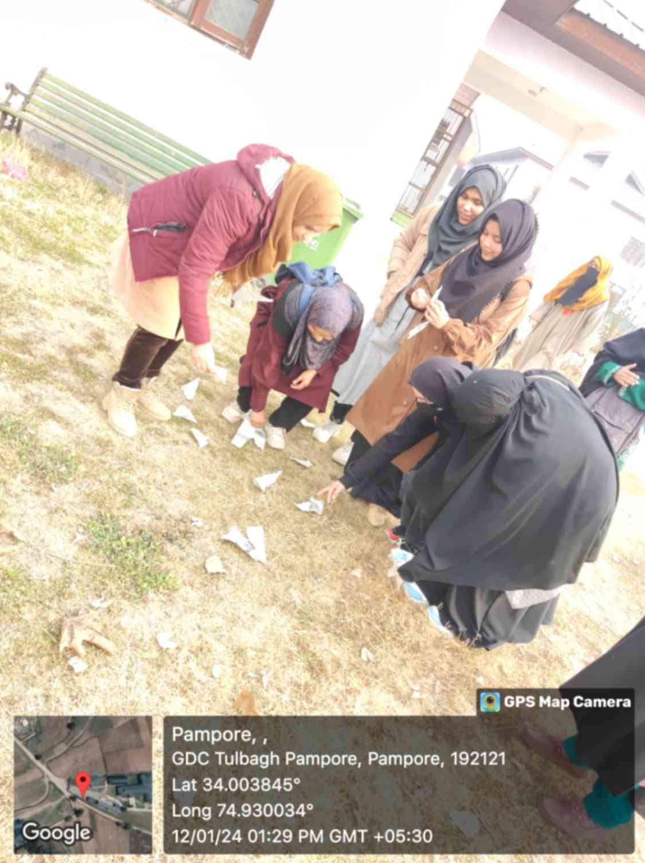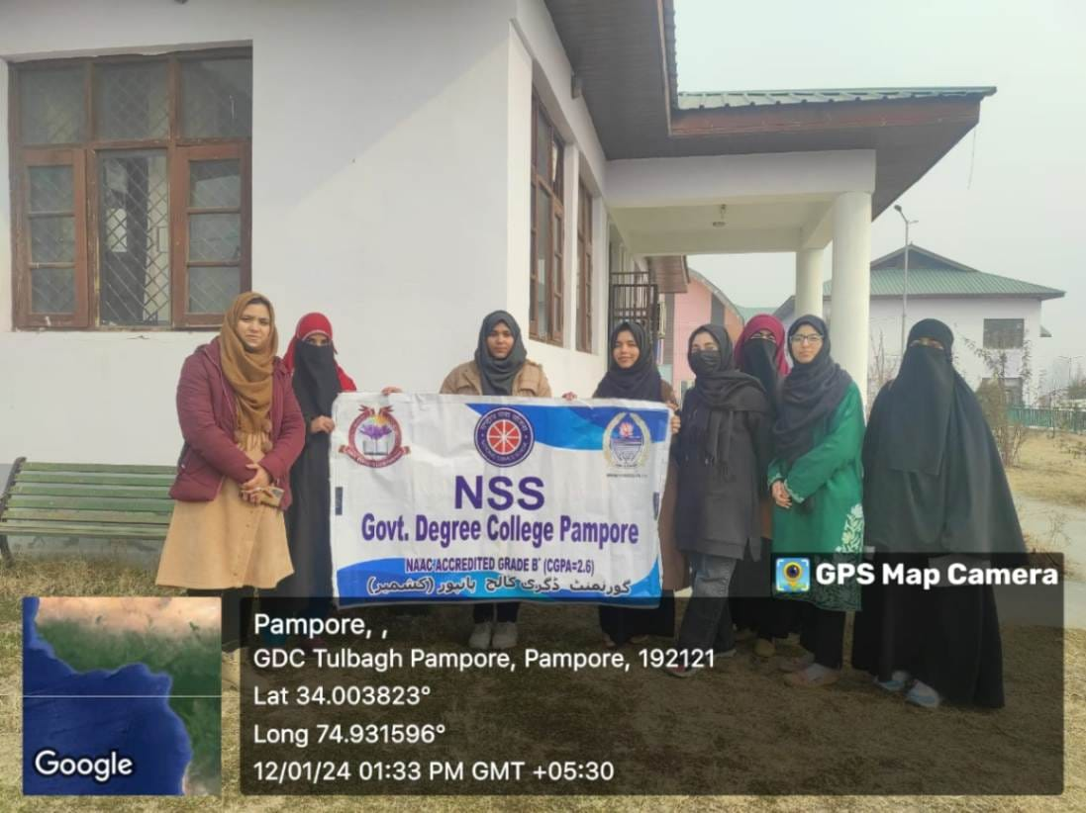
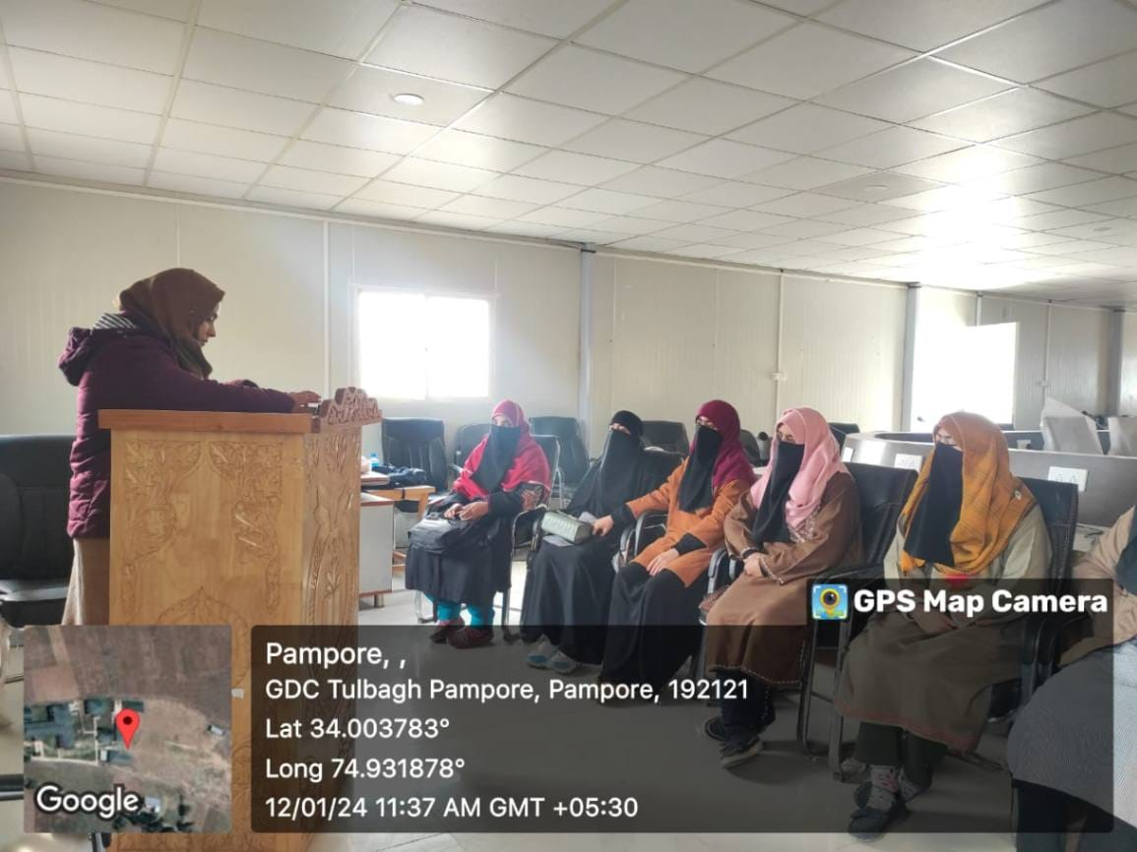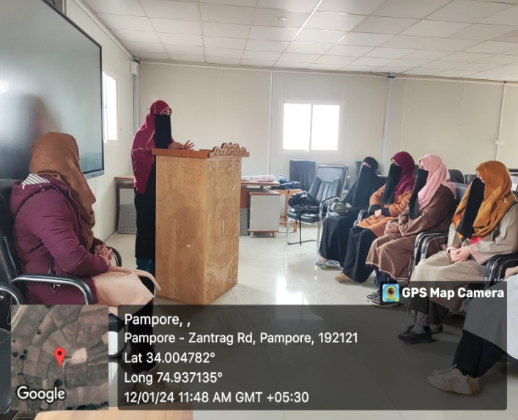

Day-2 Report: On 13th of January 2024 an online thought sharing programme was held. Students shared their thoughts on Youth Empowerment via Google form. The link of the Google form was shared through the WhatsApp group created for the same at 2:00 Pm. Students via Google form expressed their thoughts and views on various aspects of youth empowerment like meaning and concept of youth empowerment, how youth can be empowered, how an empowered youth can help in making India developed and help in fulfilling the dream of Viksit Bharat. Good number of students takes part in the programme. The programme ended with a thank you message shared by Prof. Kasira in the respective WhatsApp group.
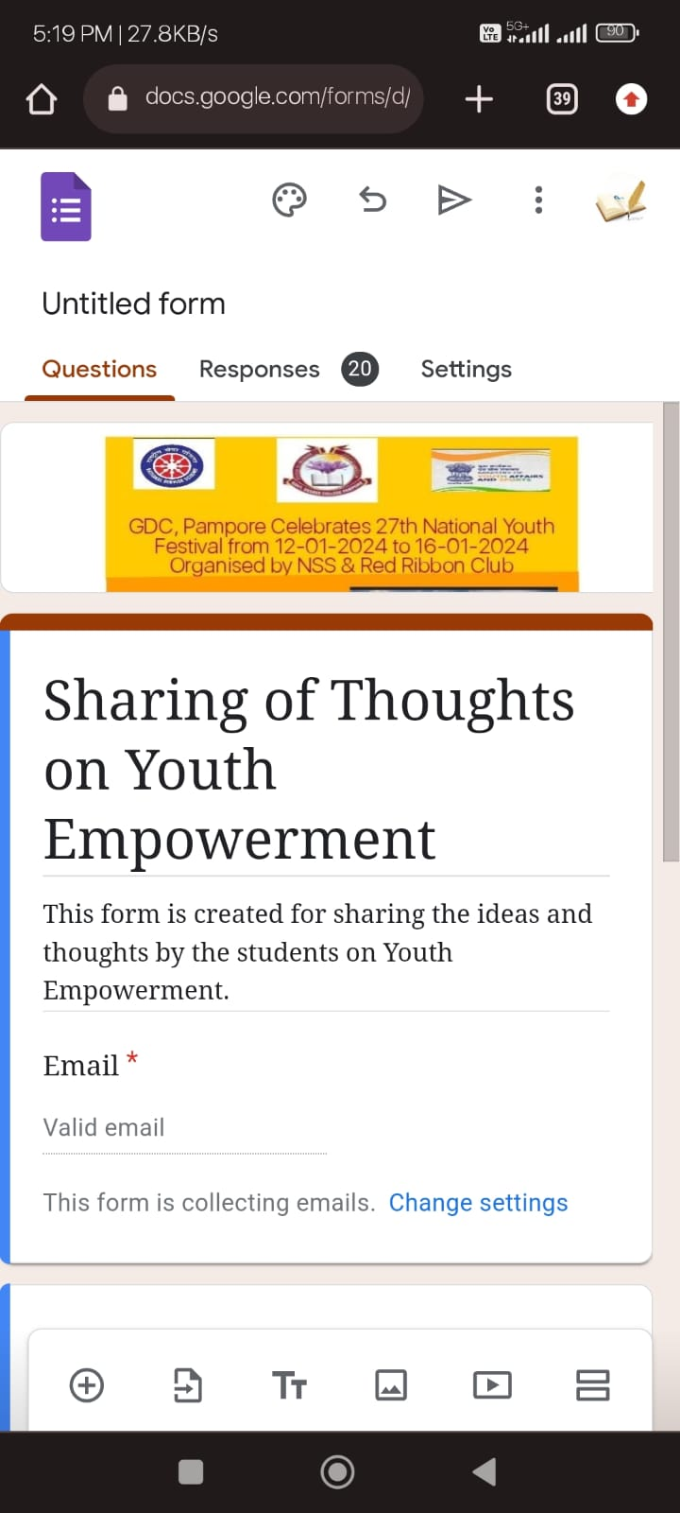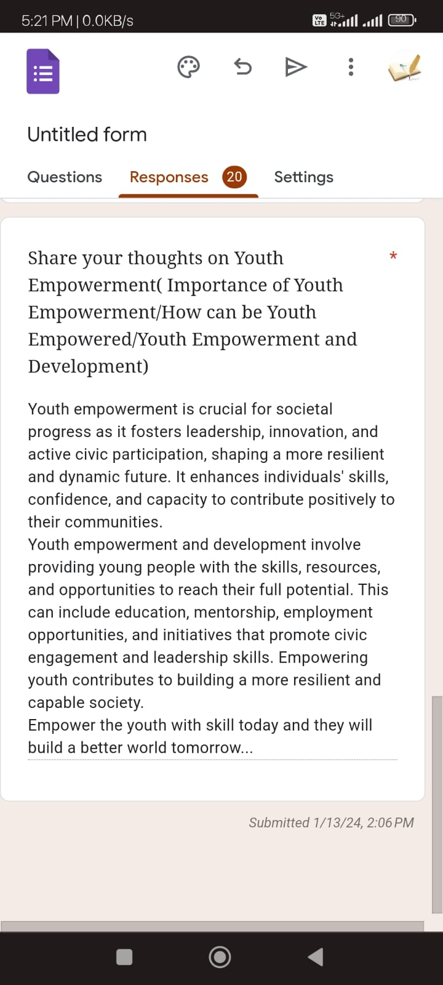

Day-3 Report: An online open mic competition on role of youth in realising the dream of Viksit Bharat was held on 15th of January, 2024. The competition started at 11:30 am on zoom meeting platform with the welcome address delivered by Prof. Kasira NSS programme officer. In her welcome address she threw light on the Viksit Bharat @2047 initiative and role of youth in making India developed by 2047. She also highlighted the objectives of the competition and also delivered the message of the Principal Prof (Dr.) Huda Galzai to the participants. Principal in her message motivated the students to be active and productive citizens of the nation. In her message she also focused on the various aspects of Viksit Bharat and how each individual can contribute to make this dream of Viksit Bharat true. The participants in this open mic competition delivered speech on youth’s role in making India a developed nation, told inspiring stories and shayris filled with hope and encouragement. At last a brief interactive session was also held among the participants. The programme ended with a formal vote of thanks proposed by one of the NSS volunteer Ateya Bashir.
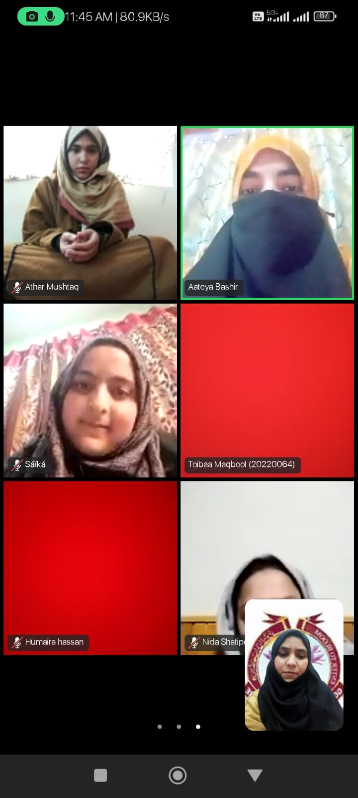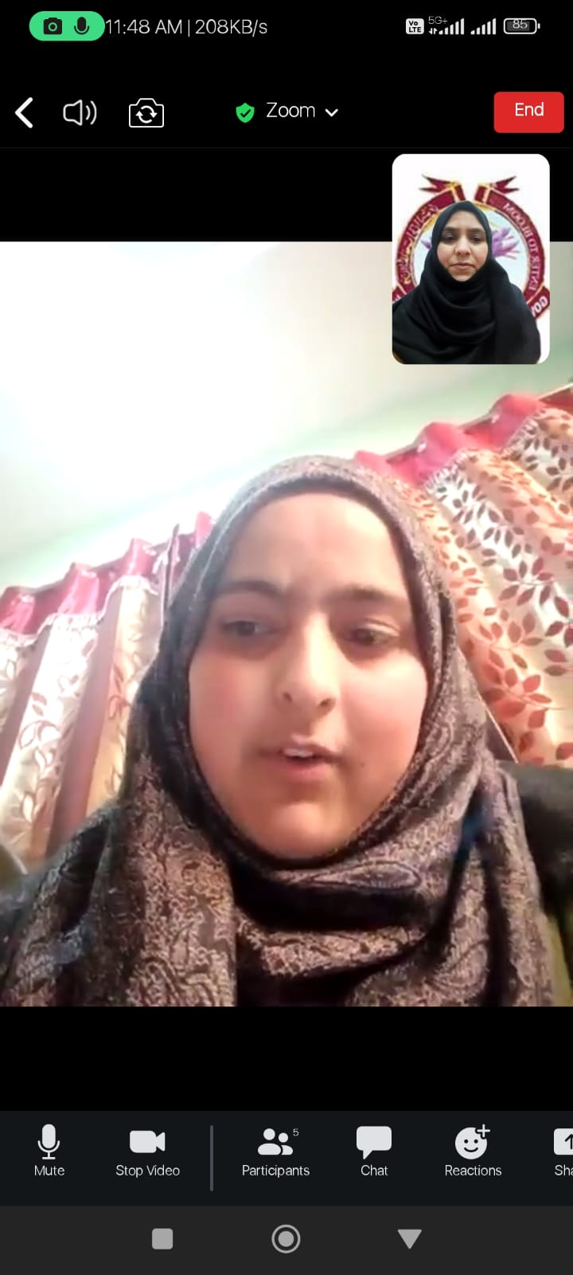

Day-4 Report: On 16th January, 2024 an online discussion on the “health concerns of youth with special mention of HIV” was held on Zoom meeting platform. Prof. Kasira welcomed the participants and briefed them about the objectives of the programme. In this discussion the participants discussed various health concerns of the youth. They shared their views and discussed about how can we live a healthy life, measures to be taken for maintaining healthy life style, how to prevent HIV and various measures that should be taken to remove the stigma associated with HIV and AIDS. The whole discussion session was very dynamic and informative. This programme provided the youth a platform to discuss their health concerns freely and seek advice on various issues related to both mental health and physical health. The session concluded with a vote of thanks proposed by Prof. Irtiza Rashid Wani, Assistant Professor Department of Music.

