**Office of the Principal**

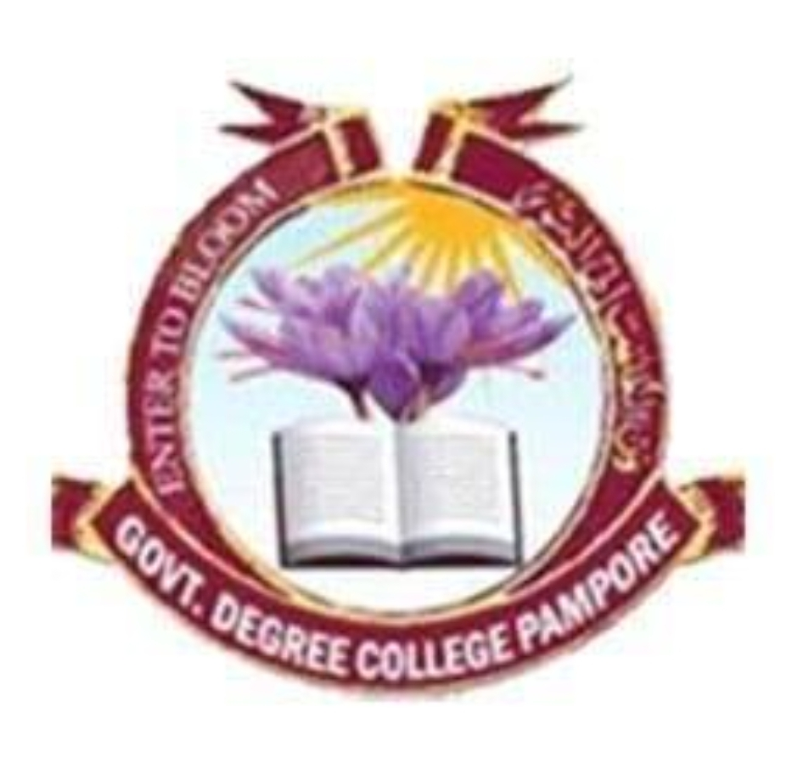

Govt. Degree College Pampore

NAAC ACCREDITED GRADE B+ (CGPA=2.6)

گورنمنٹ ڈگری کالج پانپور (کشمیر)

**Tulbagh, Pampore-192121-(Distt. Pulwama)-Kashmir**

**Cell: 9419022133, web: gdcpampore.edu.in, email:**[**principalgdcpampore@gmail.com**](mailto:principalgdcpampore@gmail.com)

**Report of the Week Long Activities held Under the Banner of World Environmental Day, 2024.**

**Activity-1 Report: Seminar on the theme Land Restoration held on 03-06-2024**

World Environment Day is celebrated every year on 5th June. This year’s World Environment Day campaign focuses on land restoration, desertification, and drought resilience under the slogan **“Our land, Our future, We are #Generation Restoration.”** In connection NSS Unit of the college in collaboration with Department of Environmental Science and Eco-Club celebrated World Environment Day by organizing a short Seminar on this year’s World Environment Day theme **‘Land Restoration, Desertification and Drought Resilience’** on 03-06-2024. The seminar started at 11 am sharp in the college conference hall with the inaugural speech delivered by Dr Irfan Khursheed Shah in which he highlighted the main drivers of land degradation and desertification across the world. In his speech, he presented insightful concepts regarding land restoration and drought resilience along with statistical data. Subsequently, the esteemed Principal Ma'am imparted her priceless knowledge and viewpoints on the significance of World Environment Day. Afterward, the students commenced their speeches, spoke on the aforementioned theme, and skilfully presented their topics in the presence of the faculty members of the college. Around 40 students attended the event and 12 students delivered their speeches on the said theme. The programme was concluded at 1:30 pm with a vote of thanks proposed by Prof. Kasira NSS programme officer.

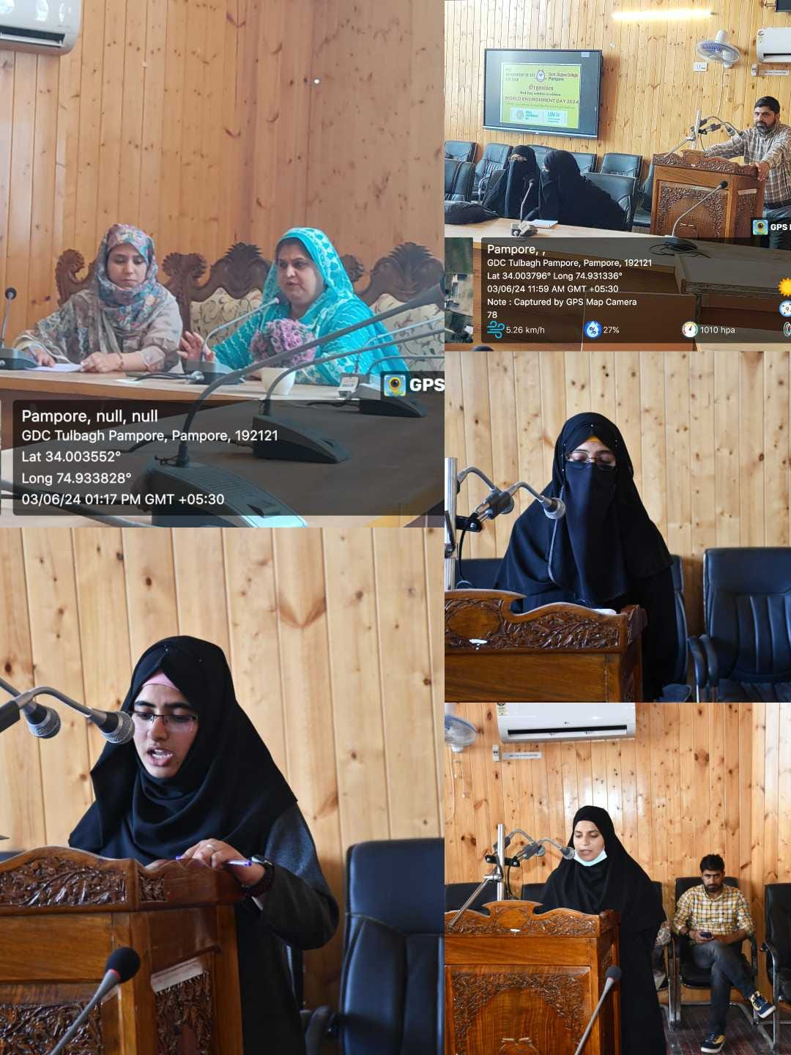

**Activity-2 Report: Painting and slogan writing competition on “Land Restoration, Desertification, Drought Resilience” held on 04-06-2024.**

Under the supervision and guidance of the Principal of the college, Prof. (Dr.) Huda Galzai, a painting and slogan writing competition was organized on June 4, 2024. The event was a part of a week-long series of activities held to commemorate World Environment Day 2024. The primary objective of the competition was to raise awareness about pressing environmental issues related to land degradation, desertification, and the importance of drought resilience. Through the creative expression of art, participants were encouraged to convey messages that promote sustainable land management and environmental conservation. 30 students from various departments participated enthusiastically in the competition. To encourage the participants NSS programme officer Prof. Kasira also took part in painting competition. The competition was divided into two categories: painting and slogan writing. Participants were given the freedom to choose their preferred medium and express their ideas creatively. The artworks were judged based on originality, relevance to the theme, artistic technique, and overall impact. A panel of experienced judges, comprising faculty members from the Department of Environmental Science, evaluated the entries and selected the winners based on the predetermined criteria. After careful deliberation, the winners in their respective categories were chosen, in painting Competition, Abida Sidiq of 4th semester, Tanzeela Rashid of 4th semester and Rayess Nisar of 2nd semester were declared as 1st , 2nd and 3rd, respectively. In slogan writing competition Nida Jan of 4th semester acquired 1st position, Rayees Nisar 2nd position and Nargis Firdous and Seerat ul Nisar acquired third position. The winners were awarded certificates of appreciation to recognize their artistic talents and efforts in spreading environmental awareness. Their artworks will be prominently displayed within the college premises to inspire others and serve as a reminder of the importance of environmental stewardship.

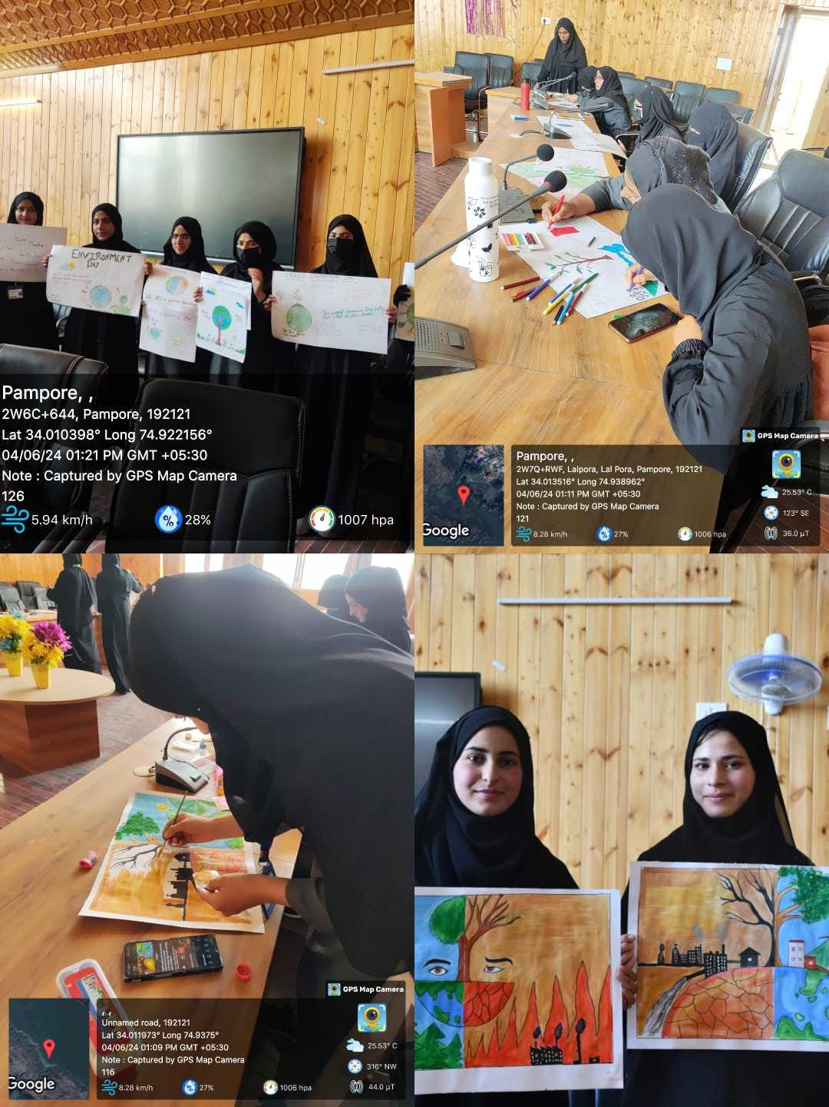

**Activity-3 Report: Environmental Awareness and Cleanliness Drive at adopted village Chandhara and adopted Govt. Middle School Krencho held on 05-06-2024.**

The NSS Unit in collaboration with Department of Environmental science and ECO Club held Cleanliness Drive at adopted village Chandhara’s Habba Khatoon Spring and its outlet on 5th June, 2024. NSS volunteers, Eco-Club members and students of Environment Science accompanied by NSS programme officer Prof. Kasira, Prof. Irtiza Head Department of Music, Dr. Irfan Khursheed Shah (HOD, Environmental Science), Dr. Shabir Hussain (HOD, Chemistry, Dr Iqbal Malik (HOD, Islamic studies) and Dr. Jehangir guest faculty departed from the college at 10:30 am. The team visited the Chandhara Spring which is located at a distance of about 5 km from the college and different types of waste material were collected from the spring in the form of polythene bags, plastic bottles, shampoo wrappers and clothing and finally the said spring was thoroughly cleaned including its outlet. The cleanliness drive was followed by awareness campaign and interactions with the local community members. During the awareness programme, Dr. Irfan Khursheed Shah and Prof. Iqbal Malik discussed their meaningful and inspiring thoughts for World Environment Day and suggested the essential preventative measures for managing and safeguarding the spring. Following that, the team travelled to the adopted Government school in Krencho, which is about 3 km from the college. There, Dr. Irfan Khursheed Shah gave a keynote address on this year's theme, which is land restoration, desertification and drought resilience and explored his views with students. Following that, refreshments were given to the students and finally the team returned the college back at 2:30 pm. Around 50 students including NSS Volunteers of the college participated in the drive.

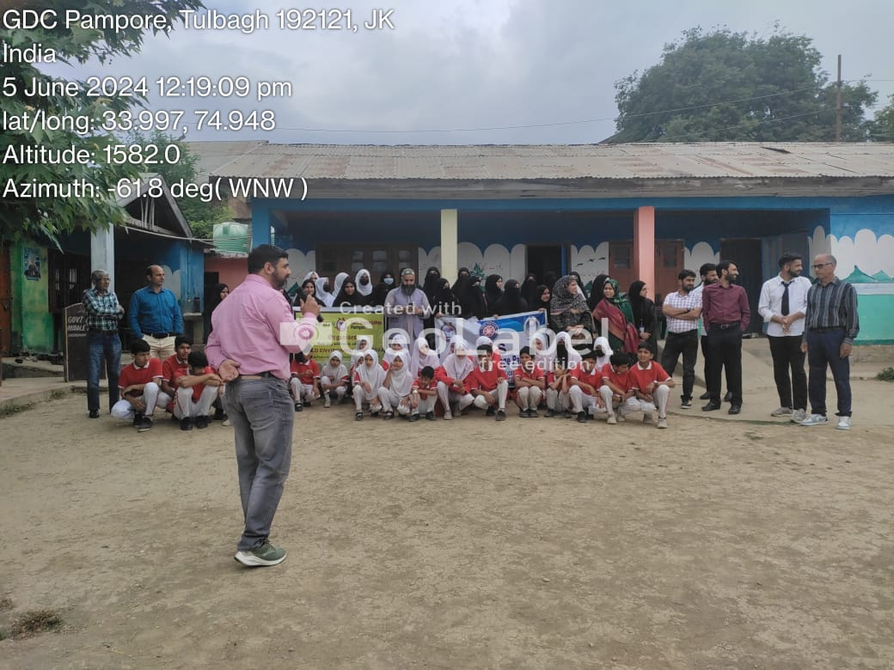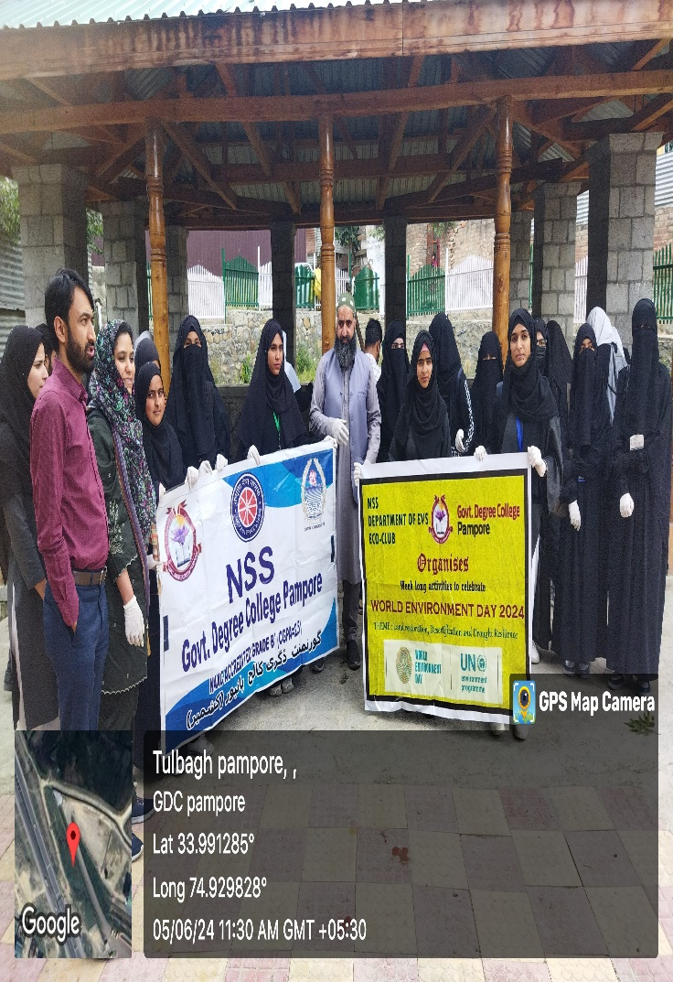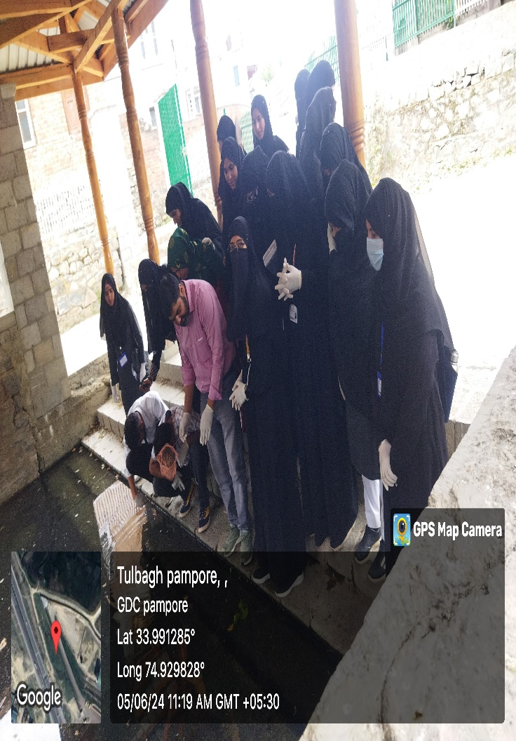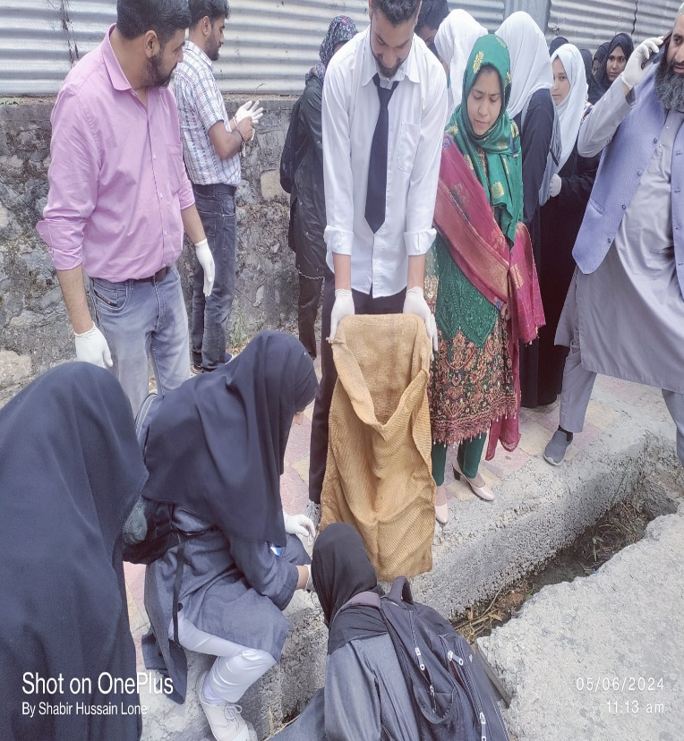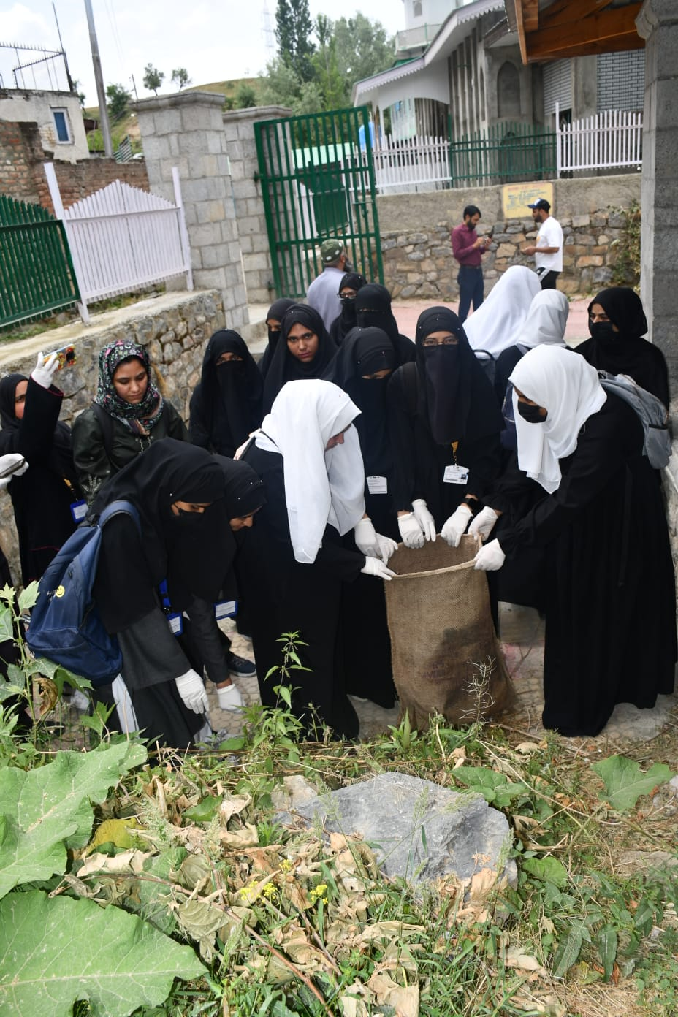

**Activity-4 Report: Valedictory Function of Week Long Activities held Under World Environmental Day, 2024 held on 08-06-2024.**

Under the visionary leadership of Principal Prof. (Dr.) Huda Galzai, Department of Music in collaboration with NSS and Department of Environmental Science held a valedictory function on June 8, 2024, to commemorate the conclusion of World Environmental Week celebrations. The event aimed to showcase the role of music in raising awareness about environmental issues and inspiring action towards sustainability. The event commenced with a college tarana sung by the students of Music department. After tarana Principal Prof (Dr.) Huda Galzai delivered a welcome address, in which she threw light on various environmental issues that we are facing today. She advised the students to act locally and think globally. She also said each one of us can act and contribute towards the protecting the earth. After that a mesmerizing poetry recitation were presented by Aetiya Bashir, a Student of 4th Semester, who eloquently presented the timeless verses of Shiekh ul Alam. The poetry, with its profound themes of nature, spirituality, and interconnectedness, captivated the audience with its beauty and depth. Following the poetry recitation, a thought-provoking rap song highlighting environmental concerns was performed by Kamraan a student from Music department. The lyrics, crafted with precision and passion, addressed pressing issues such as climate change, pollution, and deforestation, urging listeners to take action and protect our planet for future generations. A harmonious group song was performed after rap song. The group song showcased the collaborative effort and creativity of music students. The performance, inspired by the beauty of nature and the urgency of environmental conservation, left a lasting impression on the audience, reinforcing the power of music as a tool for social change. The culmination of the program featured a brief yet meaningful certificate distribution ceremony, where participants were acknowledged for their dedication and efforts in promoting environmental awareness through the power of speech, art and music. Principal Prof. (Dr.) Huda Galzai along with the faculty presented the certificates to the students, commending them for their contributions to the cause of environmental sustainability.

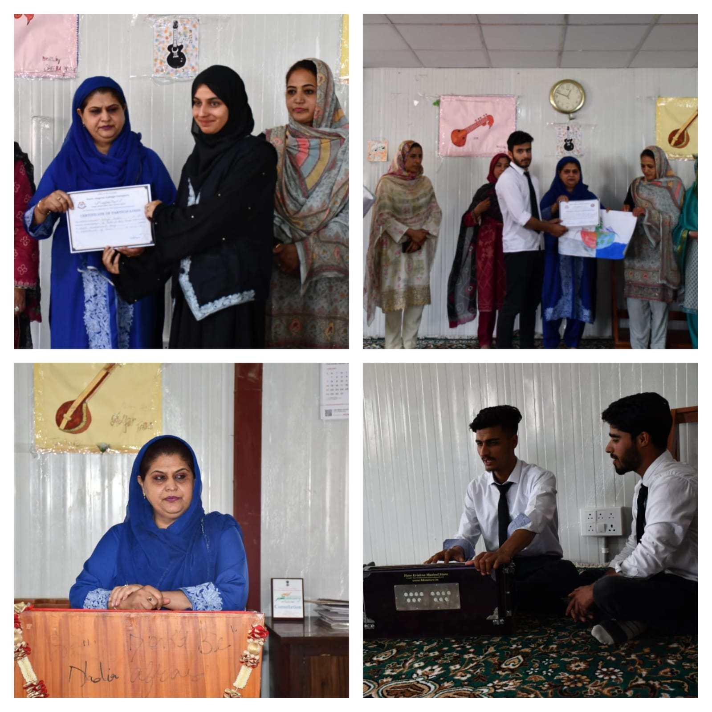

Principal