Office of the Principal
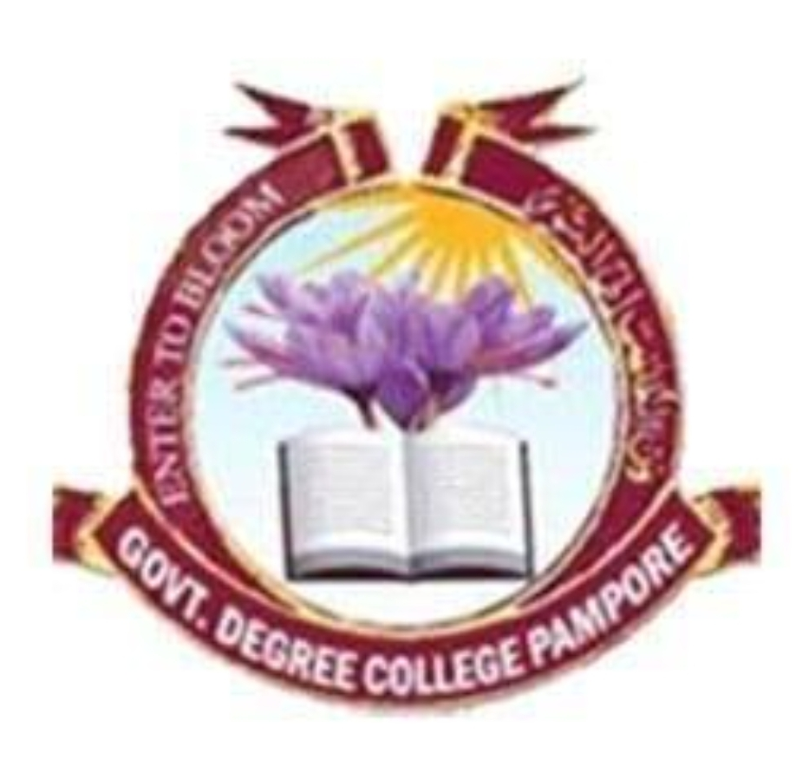
Govt. Degree College Pampore
NAAC ACCREDITED GRADE B⁺ (CGPA=2.6)
گورنمنٹ ڈگری کالج پانپور (کشمیر)
Tulbagh, Pampore-192121-(Distt. Pulwama)-Kashmir
Cell: 9419022133, web: gdcpampore.edu.in, email: principalgdcpampore@gmail.com

Report of the activities held under World No Tobacco Day on 01-06-2024 at GDC Pampore
The Department of Music in collaboration with the National Service Scheme (NSS) unit and NCORD of the college under the able guidance of the Principal Prof.(Dr.) Huda Galzai held a series of activities to commemorate World No Tobacco Day, 2024. The event aimed to raise awareness about the harmful effects of tobacco consumption and promote a tobacco-free lifestyle among students and the community.
The event was formally inaugurated by the Principal of the college Prof. (Dr.) Huda Galzai. She welcomed the faculty, participants and students. During her welcome address she talked about the detrimental effects of the tobacco on health of an individual and overall community. She advised the students to cease the usage of tobacco and lead a tobacco free life and make your society tobacco free.
The event commenced with playing of College Tarana which was followed by a captivating skit performance staged by the students of Department of Music, highlighting the harmful impact of tobacco use on health and society. Through compelling storytelling and dramatic portrayal, the skit conveyed the message of the importance of quitting tobacco and preventing its initiation, especially among youth. Following the skit, an engaging Ladisha act was performed by Tanzeel Nazir a student of 2nd Semester in which he poetically highlighted the consequences of tobacco on society
The highlight of the event was an anti-tobacco rally in which students, faculty members, and NSS volunteers marched through the campus and surrounding areas, carrying banners, placards, and slogans advocating for tobacco control and cessation. The rally served as a visible demonstration of collective determination to combat tobacco use and promote public health.
A certificate distribution ceremony was also held at the end of the programme in which participants were awarded with certificate of appreciation. The proceedings of the programme were conducted by Saika Bashir a Student of 4th semester and the formal vote of thanks was proposed by Prof Irtiza Rashid Wani, Head Department of Music. The report of the programme was prepared by Prof Kasira, NSS Programme Officer.

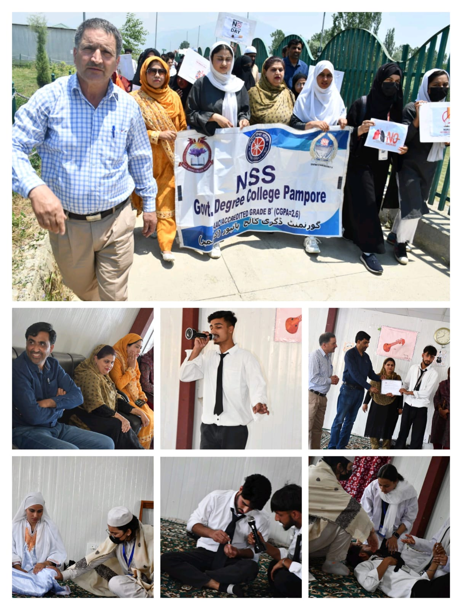

Principal GDC Pampore

