Office of the Principal
Govt. Degree College Pampore
NAAC Accredited B+
گورنمنٹ ڈگری کالج پانپور(کشمیر)
Tulibagh, Pampore - 192121 - (Distt. Pulwama)- Kashmir
Cell: 9419022133, Web: gdcpampore.edu.in Email: gdcpampore@gmail.com

Marathon on the theme ‘Digital J&K’ in connection with the observance of Digital Week on 31st of August, 2023

A Brief Report
In connection with the observance of Digital Week the college NSS unit in collaboration with college debates and seminar committee and physical education department organized a marathon on the theme ' 'Digital J &K' on 31st of August, 2023. The marathon was held under the able patronage of principal Prof. (Dr.) Huda Galzai. The marathon was flagged off by senior professor Hilal Ahmad Bakshi at 11:30 am from the college campus which later on culminated at Chungi, Tulbagh Pampore.
The said marathon was held to raise awareness about the benefits of digitization in jammu and kashmir. The students participated in the marathon with informative placards in their hands. In the said marathon many students participated actively along with NSS programme officers.

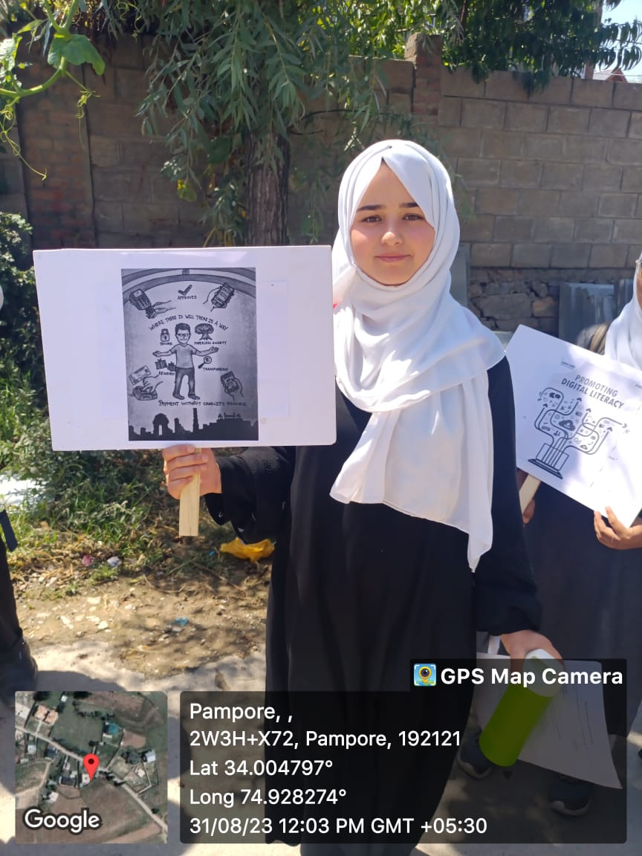
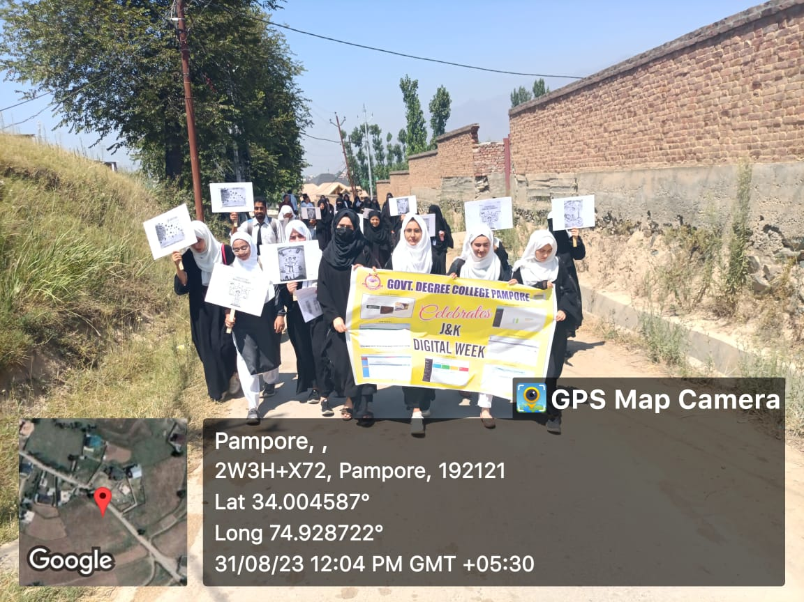
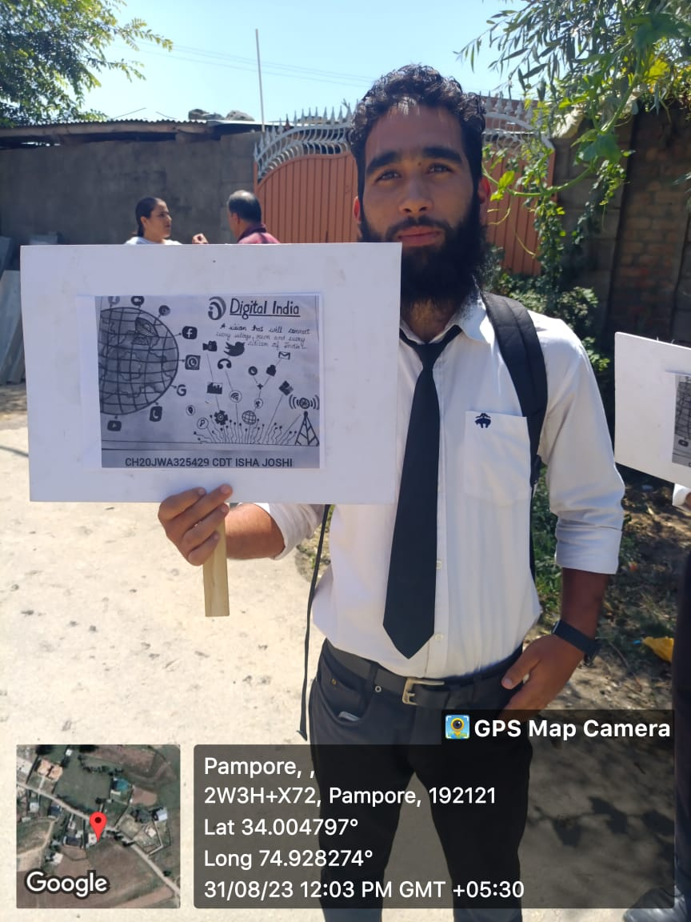
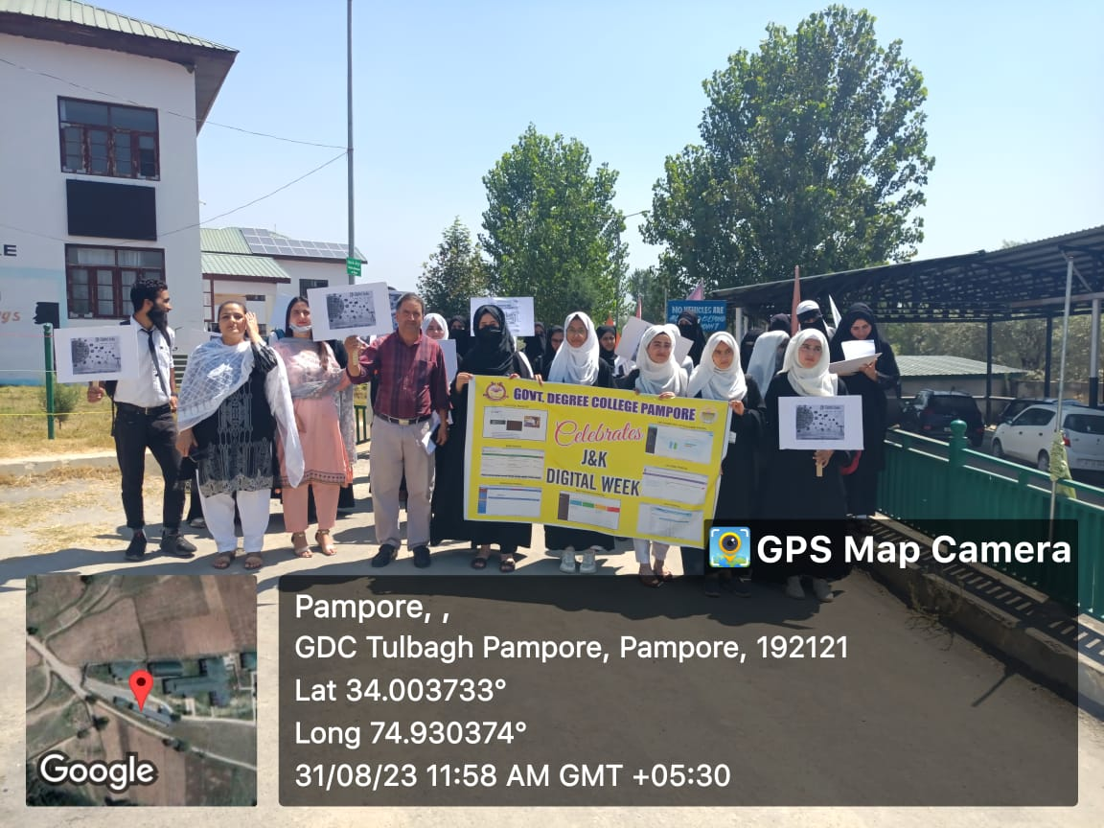
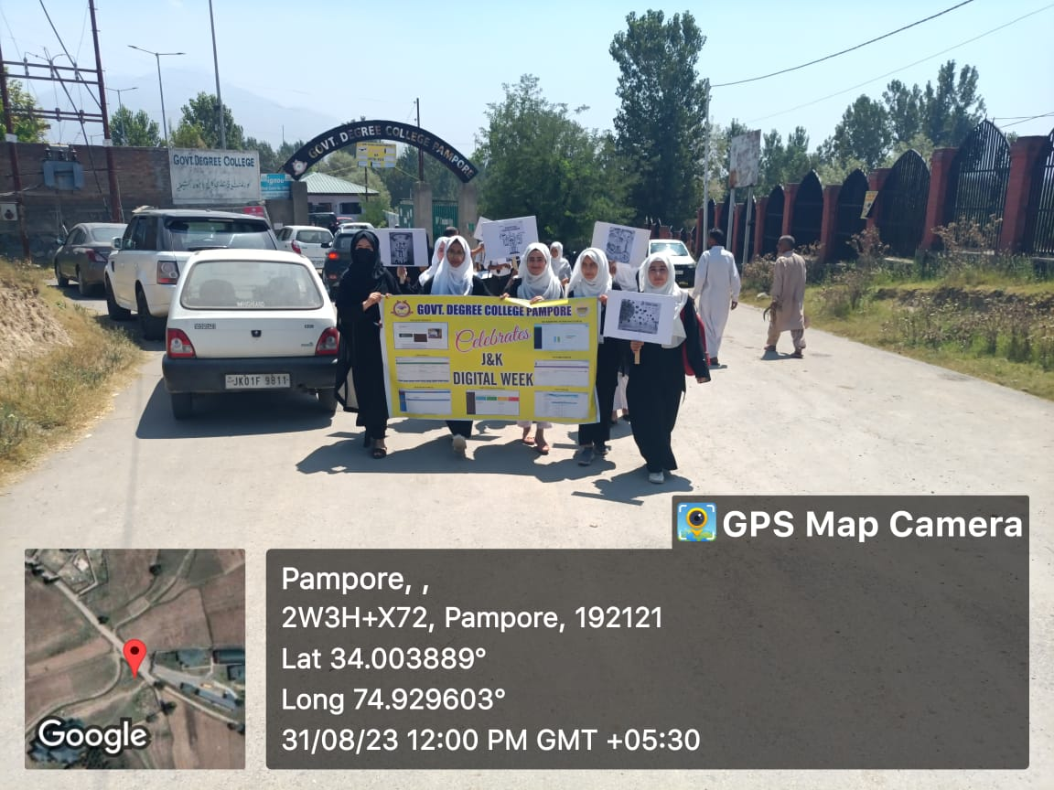
Submitted for Approval

