Office of the Principal
Govt. Degree College Pampore
NAAC Accredited B+
گورنمنٹ ڈگری کالج پانپور(کشمیر)
Tulibagh, Pampore - 192121 - (Distt. Pulwama)- Kashmir
Cell: 9419022133, Web: gdcpampore.edu.in Email: gdcpampore@gmail.com

Digital Week Celebrations
w.e.f. 30th of August, 2023

- On-Spot Painting Competition on the theme ‘Digital J&K-A Step towards Digital Empowerment of Citizens’ in connection with the celebration of Digital Week organized by College Debates and Seminar Committee

A Brief Report
In connection with the celebration of Digital Week, the college Debates and Seminar Committee organized an ‘On-Spot Painting Competition’ on the theme ‘Digital J&K- A Step towards Empowerment of Citizens’ on 30th of August, 2023 at 11:30 am in Conference Hall. The competition was held under the able patronage of Principal Prof. (Dr.) Huda Galzai.
The activity was conducted to raise awareness among the students about the ever expanding digital world and encourage them to participate in such artistic endeavours. In the competition a number of students participated actively and the following students were declared as the winners:
- Aiman Riyaz, Class Roll No. 202, 5th Semester (1st Position)
- ShakirNazir, Class Roll No. 650, 5th Semester (2nd Position)
- Adfar Farooq, Class Roll No, 274, 5th Semester (3rd Position)
- Iqrah Maqbool, Class Roll No. 303, 5th Semester (4th Position)

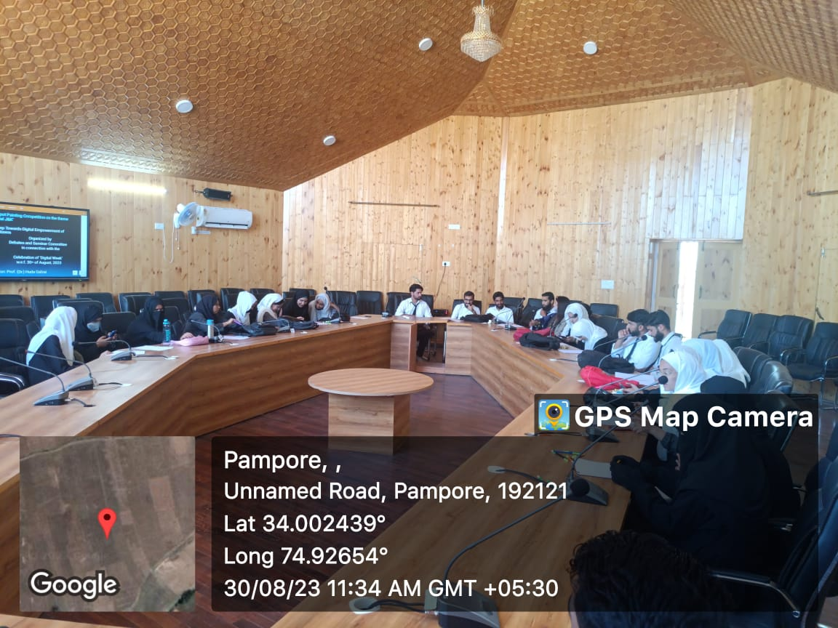
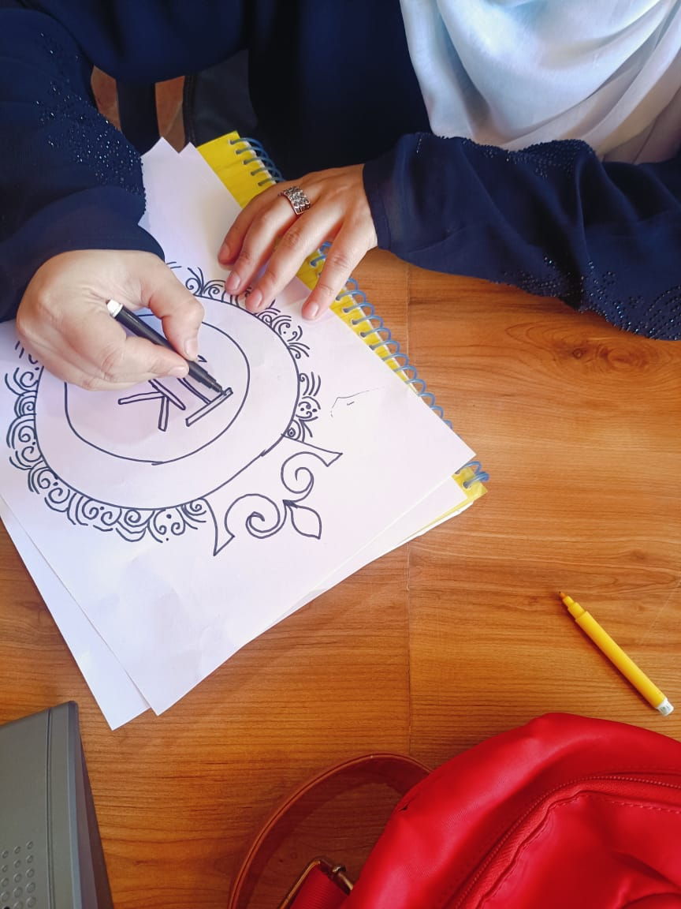
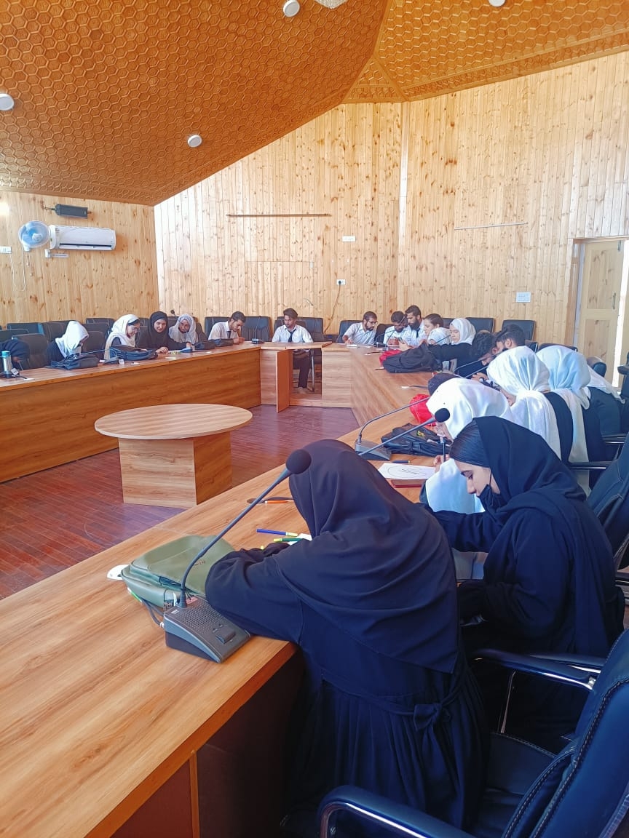
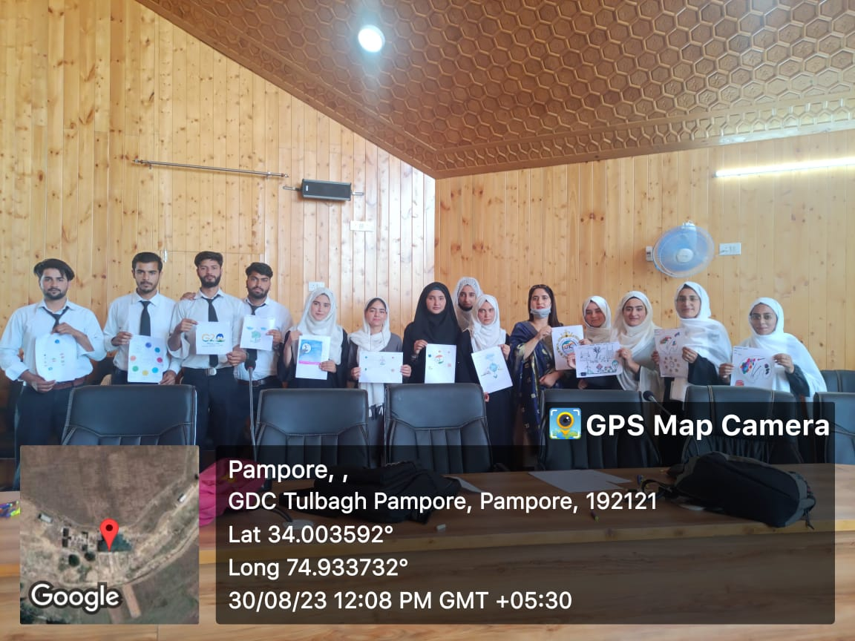

Submitted for approval

