Career Counseling Cell
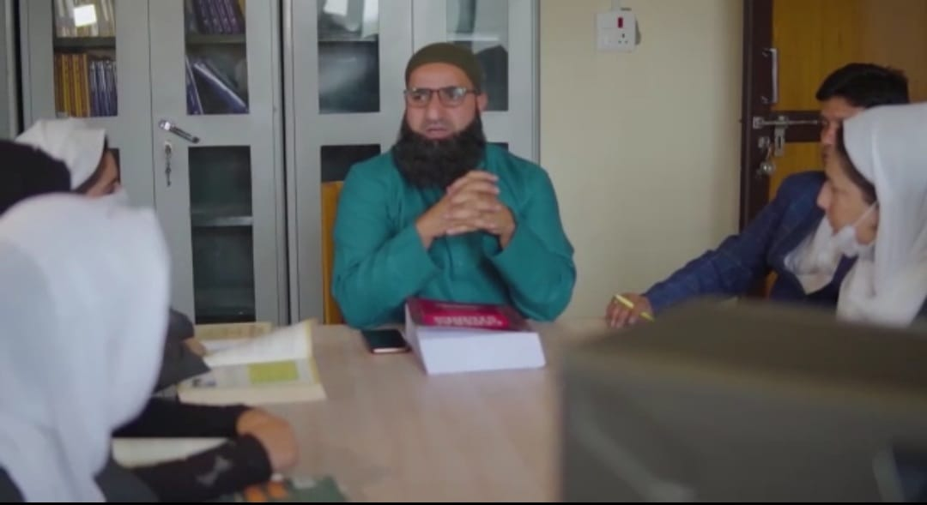

Career Counseling Cell

The Career Counseling Cell of the College is housed in the Library Block
The Career Counseling Cell caters to the Career guidance and Career development needs of the students. The CCC organizes Career awareness programmes, Workshops and events to address the overall Career needs of the Students.
Scholars of repute are invited as guest lectures. Experts from different fields interact with the students on contemporary problems of their field.
The career Counseling Cell is responsible for conducting remedial coaching classes for PG entrance exams, Workshops and Interactive sessions for Civil services aspirants and other allied examinations.

Services Offered

- Resource material for UPSC, PSC, IBPS, CAT, MAT, JAM, IEEE, JKCET and allied competitive examinations.
- Career guidance while choosing subjects for obtaining graduation during 1st year admissions.
- Helping students to identify their core competencies while opting for a Career whether in the Industry or in Academics.
- Encouraging student participation in Workshops, Seminars, Debates and other career related events.

Members

S No | Name | Designation
01 | Dr. Mohammad Iqbal Malik | Convener
02 | Dr. Shabir Hussain Lone | Member
03 | Prof. Manzoor Ahmad Hajam | Member

Few Activities

- CERTIFICATE CEREMONY OF RPL REPORT
- http://gdcpampore.edu.in/notifications/webinar-onstaying-motivated-and-transforming-dreams-into-reality-in-the-pandemic/
- http://gdcpampore.edu.in/admissions/pre-admission-mela-organised-by-gdc-pampore/
- http://gdcpampore.edu.in/news-events/scholarship-awareness-programme-on-24-02-21/

