Office of the Principal
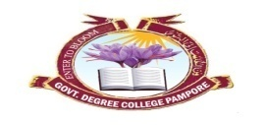
Govt. Degree College Pampore
گورنمنٹ ڈگری کالج پانپور(کشمیر)
Tulibagh, Pampore - 192121 - (Distt. Pulwama)- Kashmir
Cell: 9419022133, Web: gdcpampore.edu.in Email: gdcpampore@gmail.com

Door to Door Awareness Rally on ‘ Say No to Drugs’ organized by College NSS Unit on 2^{3rd} of February, 2023

A Report
An awareness rally and door to door campaign on the theme ‘Say No to Drugs and Yes to Life’ was organized by College NSS Unit under the able patronage of Principal Prof. (Dr.) Huda Galzai on 2^{3rd} of February, 2023. The rally commenced at 2:00 pm from the main gate of the college to the main locality of Tulbagh Area. In the said rally, students displayed informative placards and later on pamphlets abut the ill effects of ‘Drug Abuse’ were distributed among the residents of the area. In order to raise awareness among the general masses, pamphlets were distributed among the shopkeepers of the locality. In the said rally, a total of 28 NSS Volunteers along with NSS programme Officer participated actively.
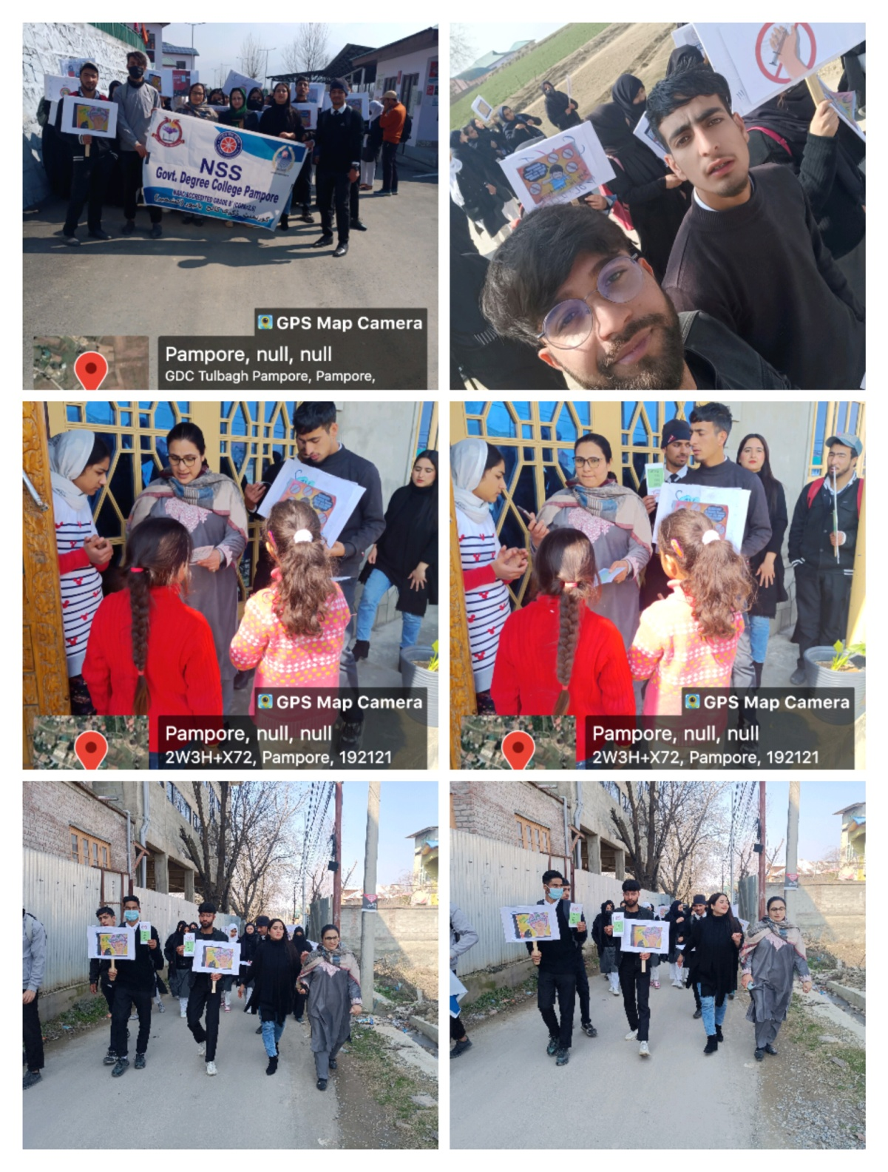

Office of the Principal
Govt. Degree College Pampore
گورنمنٹ ڈگری کالج پانپور(کشمیر)
Tulibagh, Pampore - 192121 - (Distt. Pulwama)- Kashmir
Cell: 9419022133, Web: gdcpampore.edu.in Email: gdcpampore@gmail.com

Painting/ Poster Competition on the theme ‘Say No to Drugs’ organized by College Debates and Seminar Committee on 2nd of March, 2023

A Report
A Painting/ Poster Competition on the theme ‘Say No to Drugs and Yes to Life’ was organized by College Debates and Seminar Committee under the able patronage of Principal Prof. (Dr.) Huda Galzai on 2nd of March, 2023. The competition commenced at 11:00 am in the morning and 20 students participated in it.
The programme was organized with the intention of raising awareness among students and many beautiful posters/ paintings were made by students reflecting their ideas on the growing menace of drug abuse.
The following students were declared winners:
1st position: Midhat Majeed, BG 2nd Semester
2nd Position; Maroofa Jan, BG 4th Semester
3rd Position: Shakir Nazir, BG 4th Semester

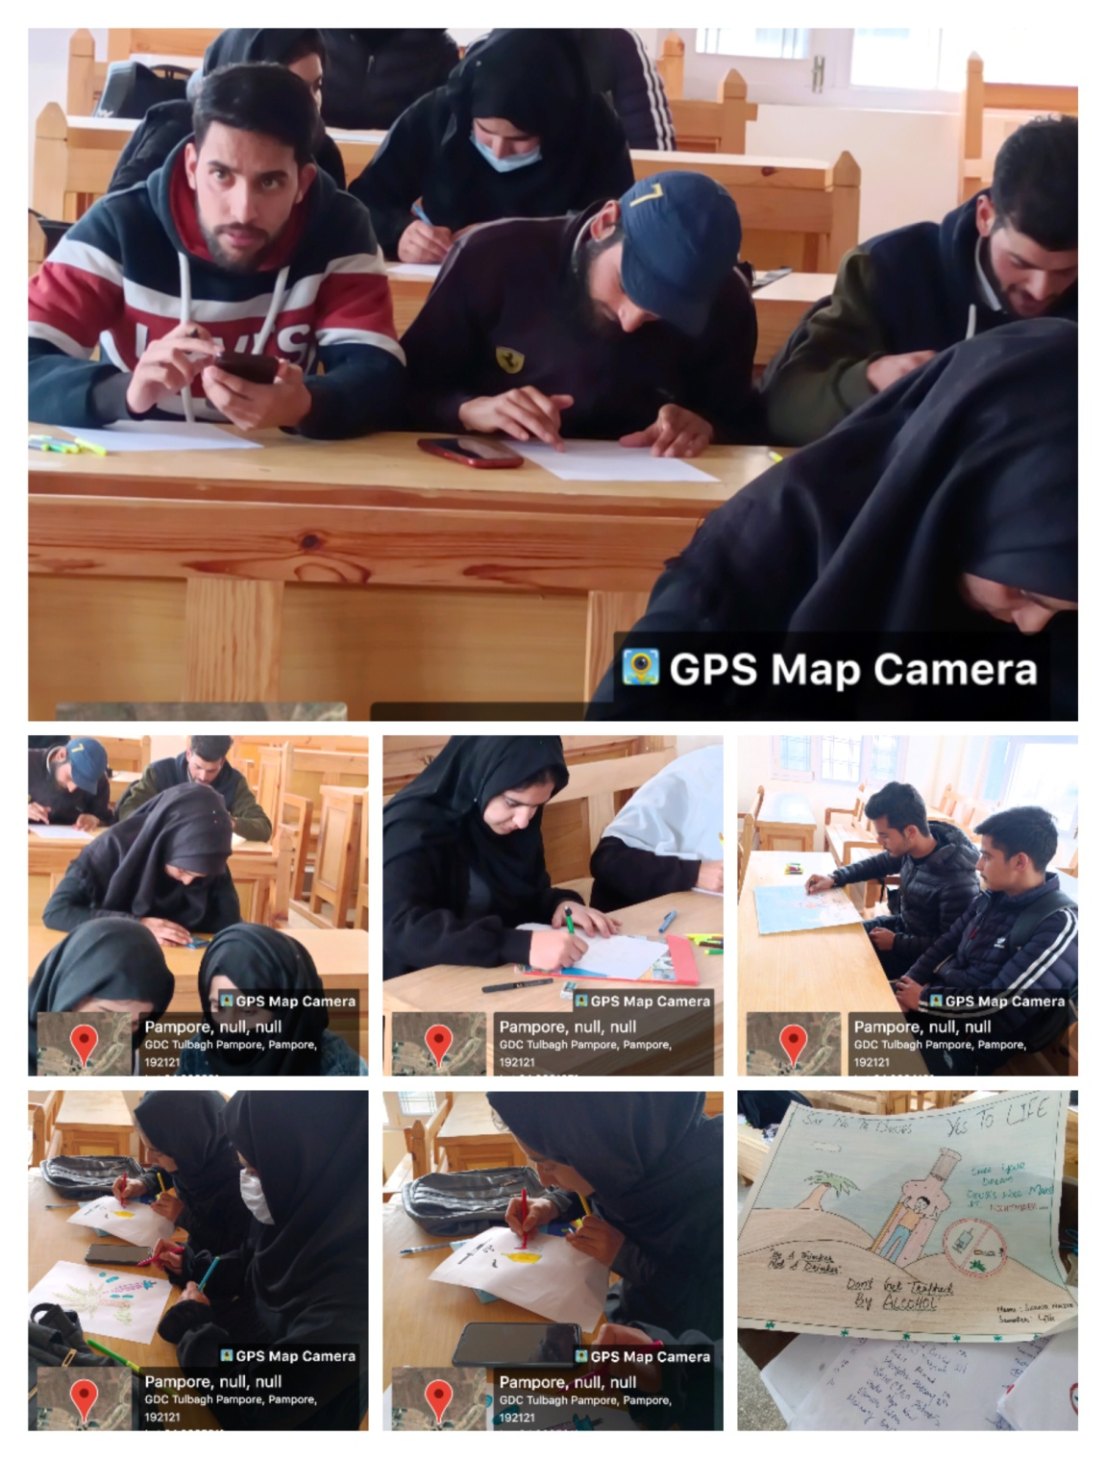

Office of the Principal
Govt. Degree College Pampore
گورنمنٹ ڈگری کالج پانپور(کشمیر)
Tulibagh, Pampore - 192121 - (Distt. Pulwama)- Kashmir
Cell: 9419022133, Web: gdcpampore.edu.in Email: gdcpampore@gmail.com

A Three-Day Mega Event on the observance of ‘International Women’s Day’ on 08th of March, 2023 organized by College Women Development Cell:

A Report
A Three-Day Mega Event on the observance of ‘International Women’s Day’ w.e.f. from 06th of March, 2023 was organized by College Women Development Cell under the able patronage of Prof. (Dr.) Huda Galzai.

Day 1: Run on ‘Embrace Equity’
On 06th of March, 2023 the college Women Development Cell in collaboration with the College Sports Committee organized a Run on ‘Embrace Equity.’ The run flagged off by Principal Prof. (Dr.) Huda Galzai started at 2:00 pm from within the college campus to the College Gate Number 02. In the said Run, 38 students and NSS Volunteers Participated and displayed informative placards on embracing equity among genders. The run was organized to raise awareness about the biases and gender discrimination faced by women on day-to-day basis.

Day 2: Students’ Seminar
On 07th of March, 2023 the College Women Development Cell in collaboration with Debates and Seminar Committee organized a Students’ Seminar on the theme ‘Embrace Equity.’ The Seminar commenced at 1:00 pm in the College Virtual Laboratory with the Inaugural Address by College Principal Prof. (Dr.) Huda Galzai. In the seminar many student speakers participated actively and delivered their speeches on the myriad injustices and discriminations faced by women on daily basis. They even raised awareness among the audience to change the status quo and uplift women.
Following students participated in the seminar:
- Mir Mohammad Wahid
- Sakeena Nisar
- Faizan Hameed
- Mufasir Farooq
- Midhat Majeed
- Aamina Farooq
- Mohammad Salim
- Nailah Nisar

Day 3: Valedictory Ceremony
On 08th of March, 2023 the College Women Development Cell organized a ‘Valedictory Ceremony’ in collaboration with the College Cultural Committee which comprised of:
- Inaugural Address: The Valedictory Ceremony started with the Inaugural Address by Madam Principal Prof. (Dr.) Huda Galzai in which she emphasized the importance of uplifting women of our society. She stressed the need of gender neutral society in the present scenario.
- Awareness Lecture: An Awareness Lecture was delivered by Madam Nighat Jan, the special guest for the day. The budding poet stressed on the need of raising awareness among general masses about various aspects of gender discrimination. She also recited two of her poems which highlighted the biases faced by women in family and at workplaces.
- Cultural Programme: The College Cultural Committee organized many cultural items on the Valedictory Ceremony of ‘International Women’s Day.’ The Cultural Programme Comprised of a Solo Performance, Rouf and a Skit Performance.
- Felicitation Ceremony: Towards the end of the ceremony all the students who had participated in various events were felicitated by worthy Principal of the college and the Special Guest.

The Formal Vote of Thanks was presented by Co-Convenor of the College Cultural Committee, Prof. Parvez Ahmed.

