Office of the Principal
Govt. Degree College Pampore
NAAC Accredited B+
گورنمنٹ ڈگری کالج پانپور(کشمیر)
Tulibagh, Pampore - 192121 - (Distt. Pulwama)- Kashmir
Cell: 9419022133, Web: gdcpampore.edu.in Email: gdcpampore@gmail.com

Celebration of 75 years of Independence under the banner of ‘Meri Mati Mera Desh’ and Azadi Ka Amrit Mahotsav

A Brief Report
In connection with the celebration of 75 years of Independence under the banner of ‘Meri Mati Mera Desh’ and Azadi Ka Amrit Mahotsav the College NSS Unit in collaboration with the Department of Physical Education and Sports organized a series of activities on 14th of August, 202. All the activities were conducted under the able patronage of Principal Prof. (Dr.) Huda Galzai:
- Pledge Taking Ceremony (Panch Pran): The college NSS Unit organized a pledge taking ceremony (Panch Pran) in the college basketball court at 12:00 noon in which all the students and faculty members of the college participated actively. The pledge read as under:
“On the completion of 75 years of Independence we take a pledge
- To work for developed India and help it regain its rightful place as Vishvaguru by 2047
- To remove any traces of colonial mindset
- To take pride in our cultural and spiritual heritage
- To strengthen the unity of our nation and protect it from disruptive elements
- To carry out our duties as a citizen of this nation with honesty and to become central pillars that support India’s journey in the Amrit Kaal.”
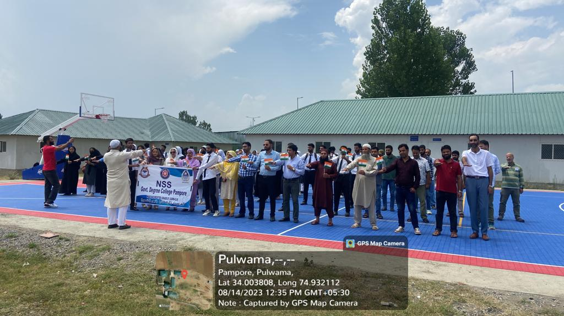

- Tiranga Rally: The college NSS Unit in collaboration with the Department of Physical Education and Sports organized a Tiranga Rally in which all the students, faculty members and Principal of the college walked in unison flaunting the Rashtriya Tricolor. The rally commenced from the college Basketball court at 12:30 pm and culminated in the nearby locality of Tulbagh.

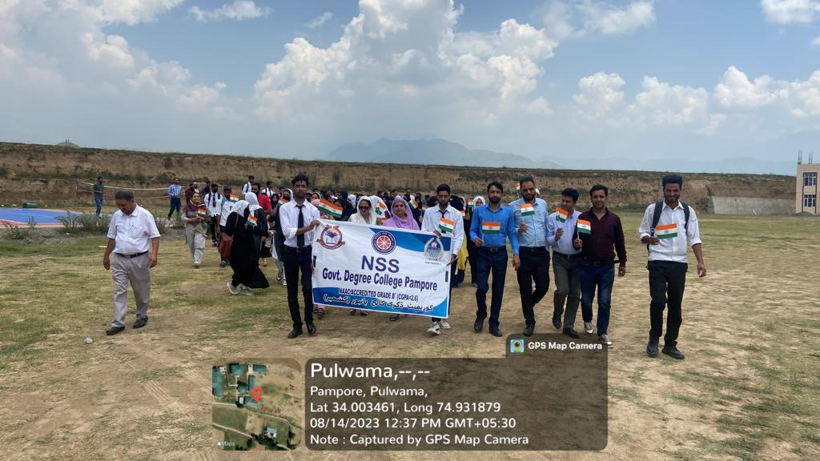
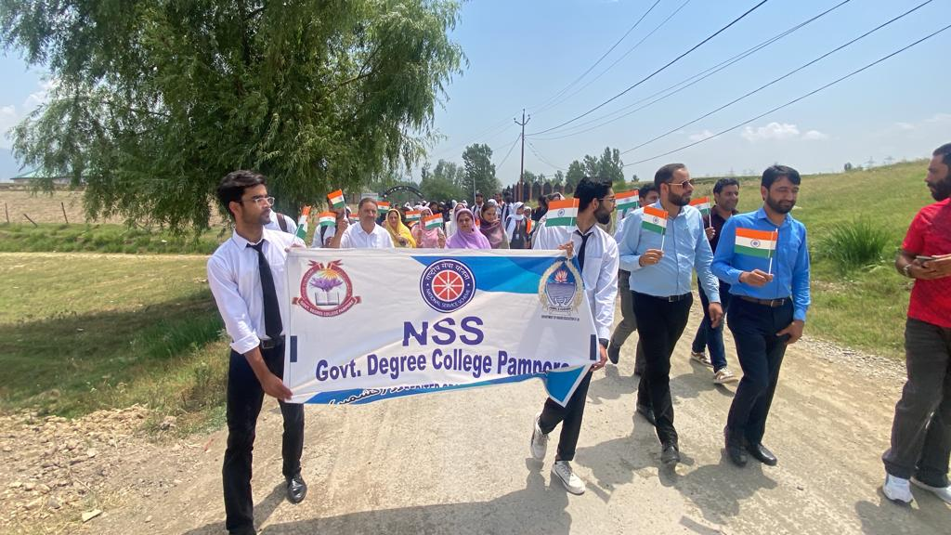

- Cleanliness Drive: The college NSS Unit organized a Cleanliness Drive at 1:00 pm in which college NSS Volunteers cleaned the premises of old Academic Block. Many NSS Volunteers participated in the said drive actively.
